**Canceling a Bonfire Project**

In the instructions,***blue words*** direct you to a button, icon, or tab*.* ***Orange words*** are a field that requires input. **Green words** are a title or subtitle.

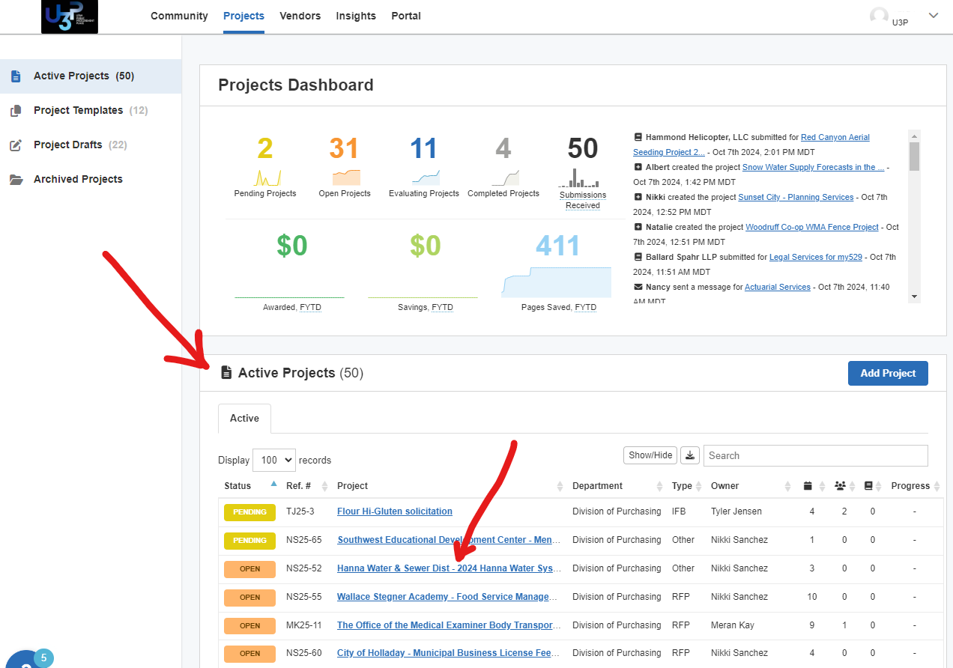

**FIND & OPEN THE PROJECT**

1. Go to the Home Screen (displayed)
2. Roll down to **Active Projects**
3. Click the ***hyperlink*** for any ***OPEN*** Project

**TO CANCEL A PROJECT**

1. Open the Project (see instructions above) From the Details Page
2. Select ***Actions*** tab
3. Select ***Cancel*** button
4. Enter the reason for cancelling and hit ***Cancel*** then ***OK***.

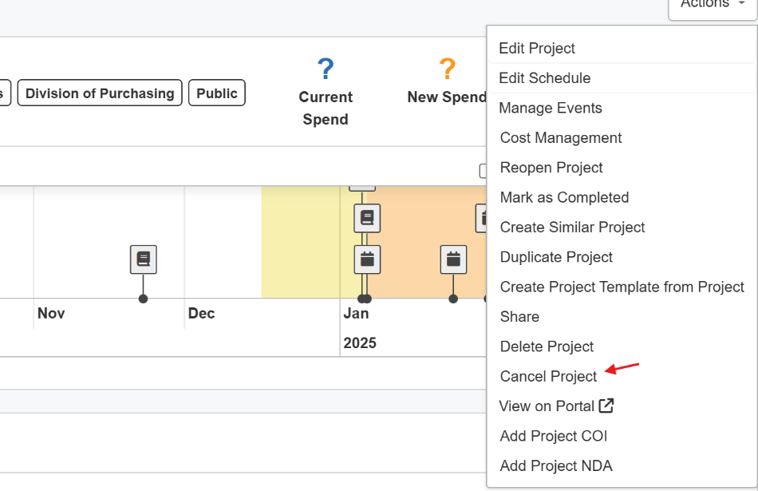

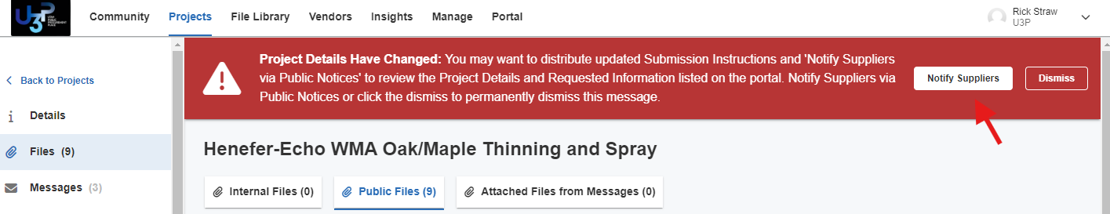

1. Click ***Public Notice***

A banner appears across the top of your project to prompt you to send a Public Notice. Click on ***Notify Suppliers.***

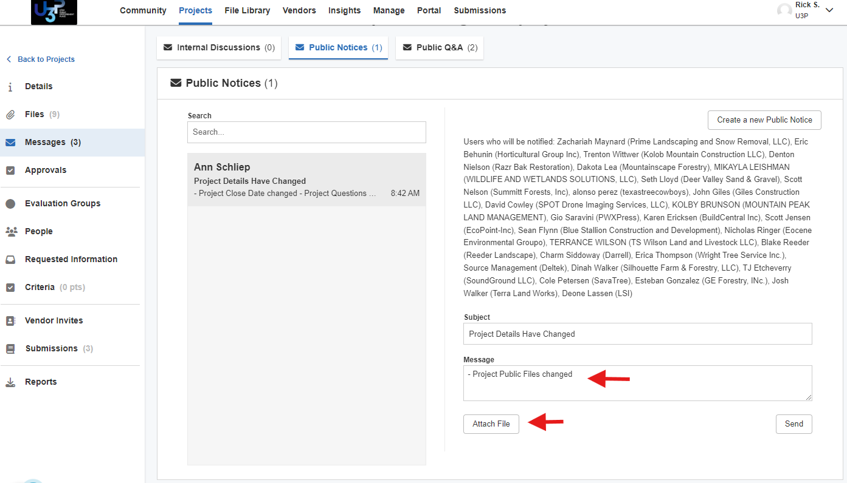

You MUST send out a Public Notice because vendors do not receive an automatic email notifications. The recipients and boilerplate language are automatically generated for you. Feel free to add any details you like to the message. Attach the cancelation memo.

**Note**: Any file you attach to a Public Notice will automatically be added to the Public Files. It’s okay that they will be in there twice. We want the vendors to receive the new/revised document via email.