**Bonfire - Jaggaer Cross Reference Instructions**

*In the instructions, all* ***blue*** *words direct you to a button, icon, or tab. All* ***orange*** *words direct you to a field.*

BONFIRE – Obtaining the URL

* Enter the solicitation
* Click **Actions** and **Preview on Portal.**
* A new tab opens.
* Copy the URL from the new tab to provide the direct link to your solicitation.

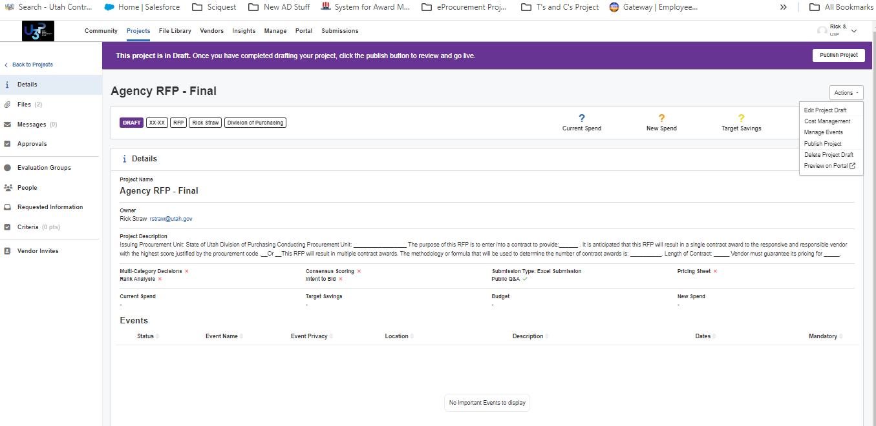



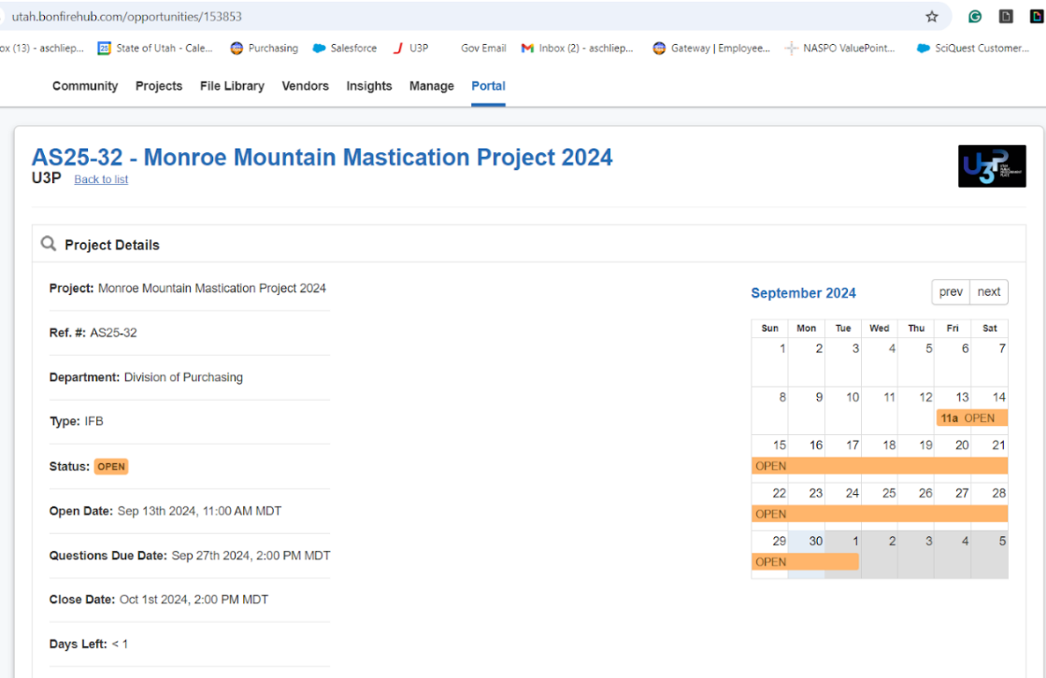

Copy the URL from the new tab to provide the direct link to your solicitation.

Purposes for URL:

1. To paste in email inviting to vendors recommended by the agency to your solicitation
2. *Through at least the end of Dec 2025, agents must copy the URL and paste that URL in a Jaggaer solicitation.*

Jaggaer: Creating Cross-Reference Post

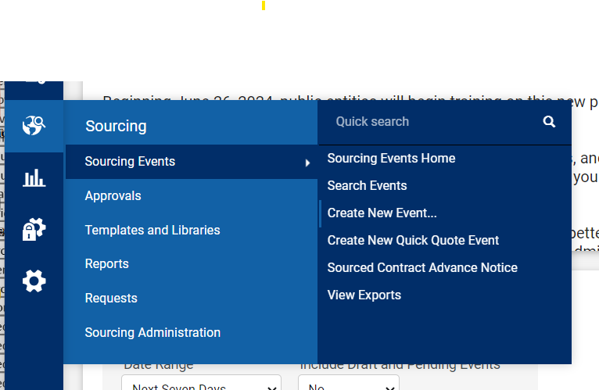

1. Select **Sourcing Events**
2. Select **Create New Events**

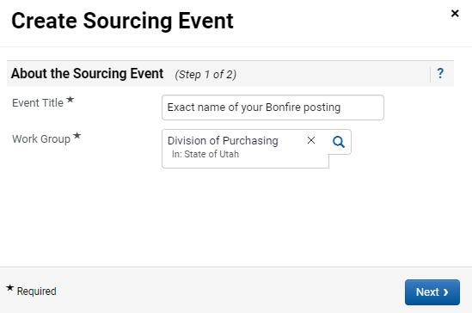

1. **Event Title**: Must match the Bonfire Project Title (solicitation name)
2. **Work Group**: Division of Purchasing (in the drop-down, State of Utah folder)
3. Click **Next**

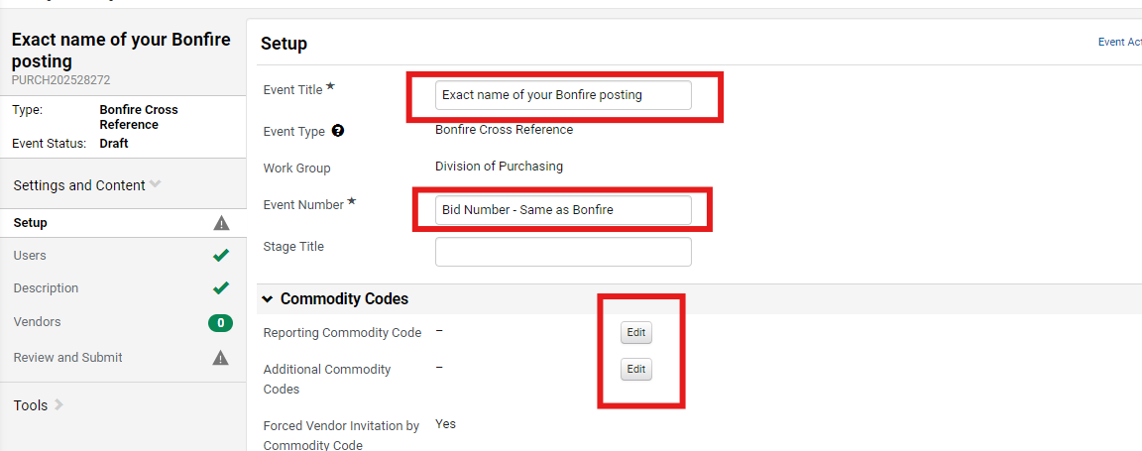

Solicitation as it appears in Bonfire

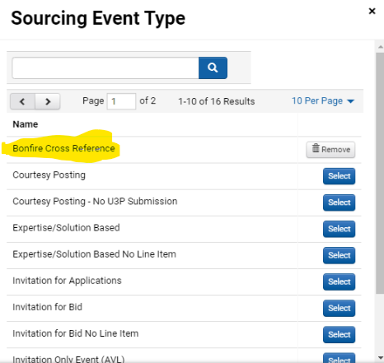

1. 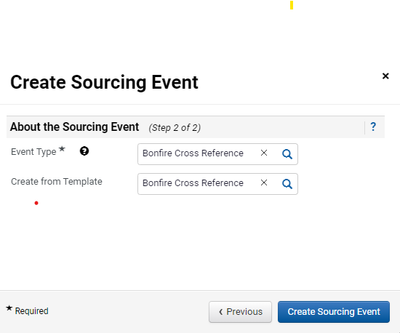Select **Bonfire Cross Reference**

The ‘About the Sourcing Event fields auto-populate. Leave them alone.

1. **Event Type**: Bonfire Cross Reference
2. **Create from Template**: Bonfire Cross Reference
3. Click **Create Sourcing Event**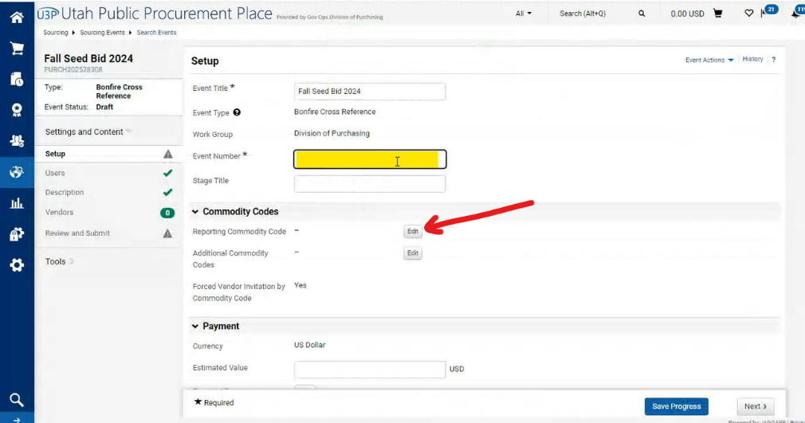
4. **Event Number:** Use the SAME solicitation number as your Bonfire posting
5. Click **Edit** by Reporting Commodity Code

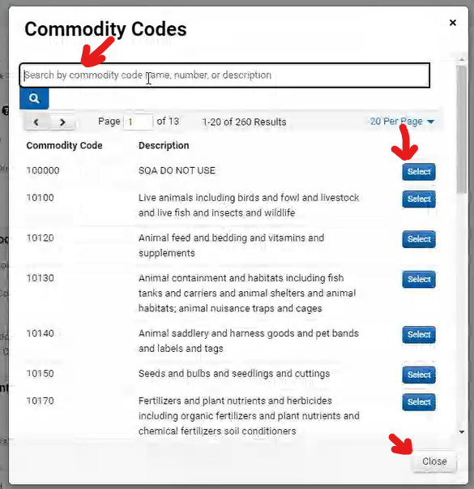

**COMMODITY CODES**

1. **Search for** and **select** the Commodity codes that are similar to what you used in Bonfire. They will not match exactly.
2. Click **Close**

**DISPLAY & COMMUNICATIONS**

1. **Public Event Short Description:** add wording similar to ‘The State of Utah is changing platforms. You can find the documents for this solicitation at: [add the Bonfire URL]’

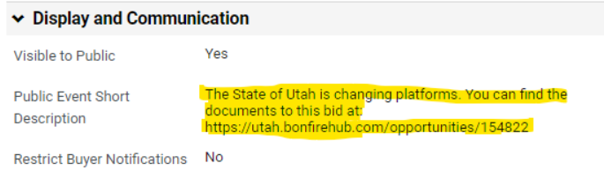

After it is saved it looks like this

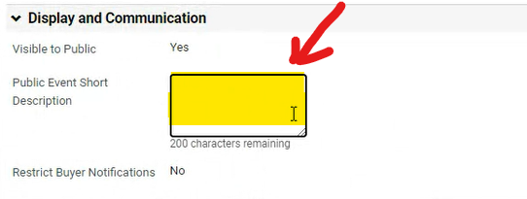

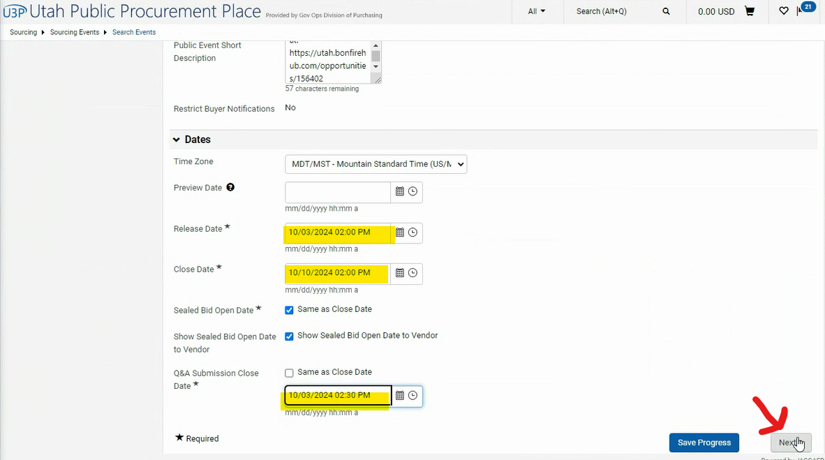**DATES Tab**

1. **Release Date**:Match the date in Bonfire project
2. **Close Date**: Match the date in Bonfire project
3. **Q&A Submission Close Date**: As Jaggaer requires time, make the time **30 minutes after the Release Date** above. No longer! We do not want questions in this system.
4. Click **Next**

**USERS Tab**

1. Follow your pod’s standard practice on the User page
2. Click **Next**

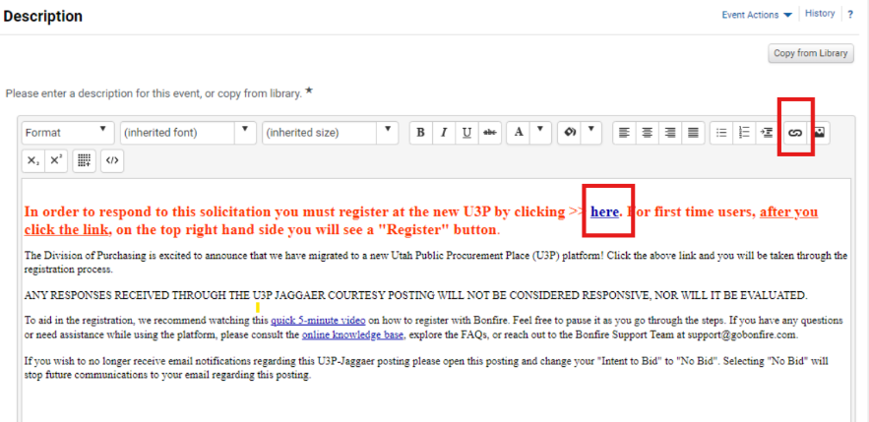**DESCRIPTION Tab**

Update Description to add the Bonfire project hyperlink:

1. Select ‘here’ in the description
2. Click the **hyperlink icon**

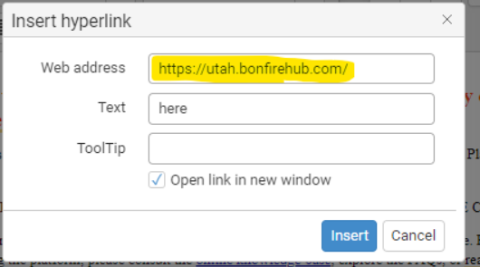

*In the pop-up box,*

1. **Web Address**: Paste the Bonfire project specific URL.
2. **Text**: leave it as ‘here’
3. Click the **Insert**
4. Click **Save Progress**
5. Select **Review and Submit** tab

**REVIEW & SUBMIT Tab**

1. Complete any review
2. Click **Submit for Approval**

