**Evaluating and Awarding in Bonfire**

In the instructions,***blue words*** direct you to a button, icon, or tab*.* ***Orange words*** are a field that requires input. **Green words** are a title or subtitle.

EVALUATING & DOWNLOADING

1. **FIND THE PROJECT**

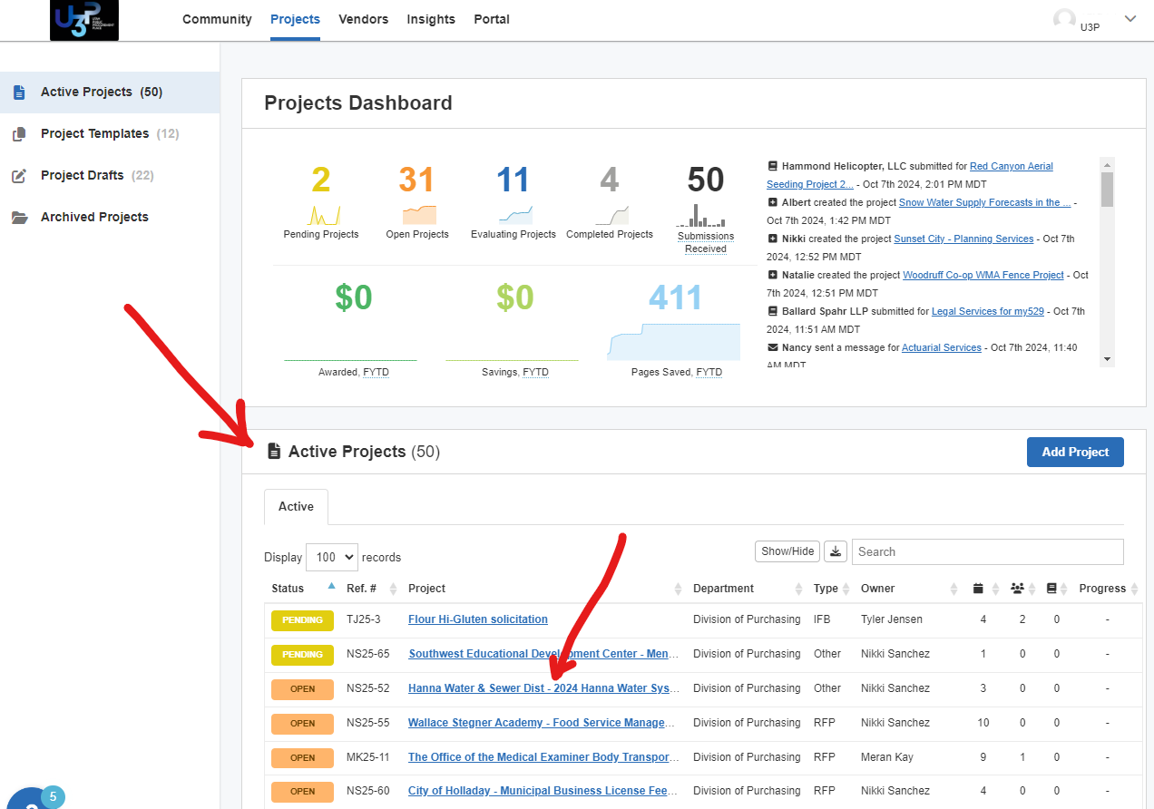

Step 1 a, b, & c

1. Go to the Home Screen (displayed)
2. Roll down to **Active Projects**
3. Click the ***hyperlink*** for any “OPEN” Project
4. **VIEW SUBMISSIONS**
5. Select ***SUBMISSIONS*** tab
6. Click the **Open** drop-down for any vendor
7. Click **Submission Data**

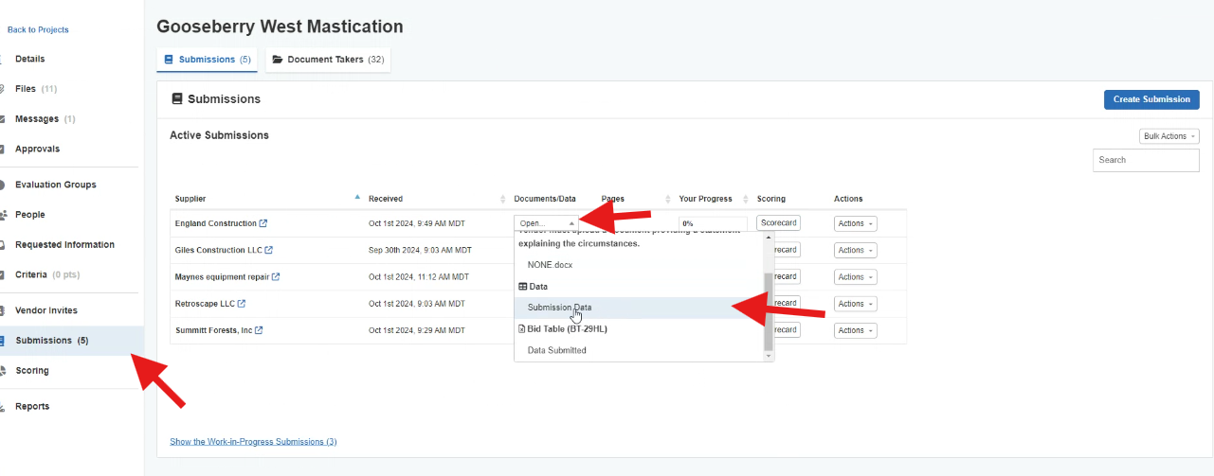

Step 2 a, b, & c

The Proposal Data Window opens.

Proposal Data Window

This window allows you to review the answers to the Requested Information Criteria. The solicitation questions & criteria are the first row (Blue arrow). Each vendor’s responses are on a subsequent row.

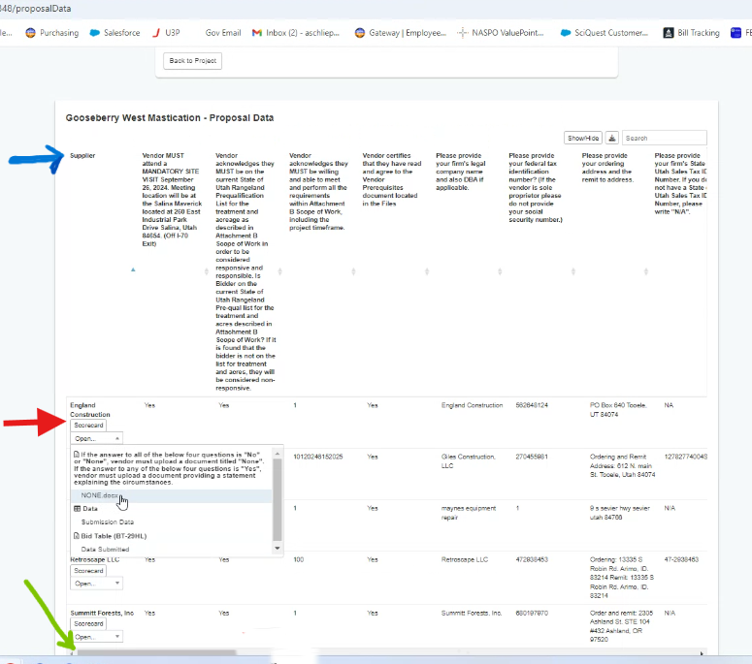

Step 3 a and Step 4 a & b

1. **VERIFY ANSWERS TO QUESTIONS**

You must perform the initial review and check that the vendor answered the mandatory minimum and other questions correctly

1. Use the scroll bar on the bottom to scroll right and left (green arrow).
2. **VIEW SUBMITTED DOCUMENTS**
3. View PDF requested documents by clicking on ***Open*** (red arrow)
4. Select ***name of the document*** you want to see.

(In this example, NONE.docx means the vendor has not been debarred or suspended)

1. **MOVE TO NEXT DOCUMENT while in a document**

*Learn how to view all the vendor’s documents without returning to the Proposal Data Window.*

1. 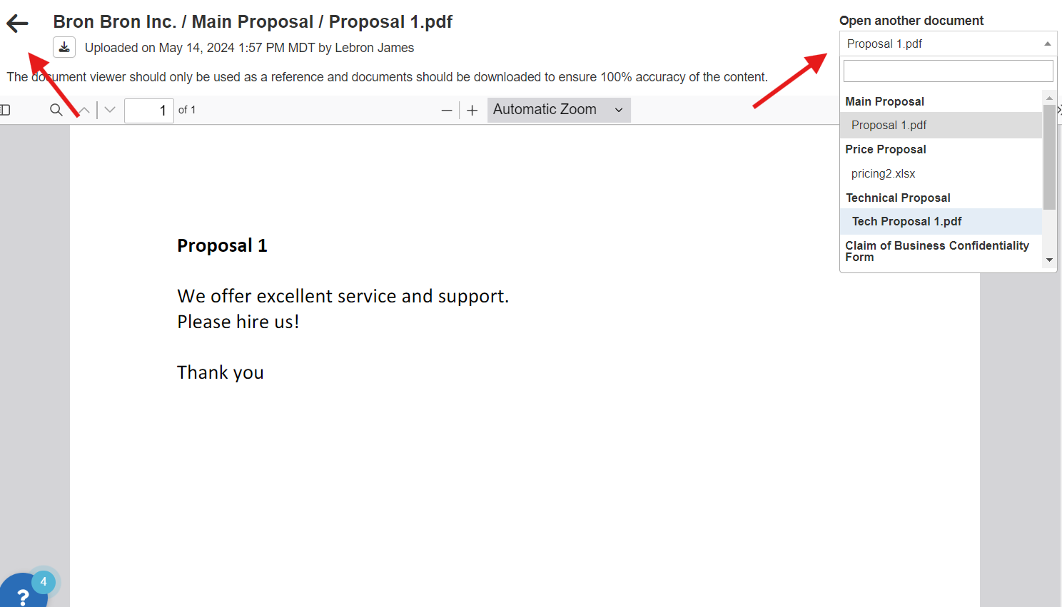Click ***Open another document*** to see any of the PDF documents that the vendor has submitted.

Note: Excel documents cannot be viewed through this viewer. They must be downloaded.

**CLOSE DOCUMENT VIEWER**

1. Click the ***back arrow*** to leave the document viewer.

**TO DOWNLOAD AND VIEW PROPOSALS**

All of the documents uploaded to Requested Information are available for download in a single zip file

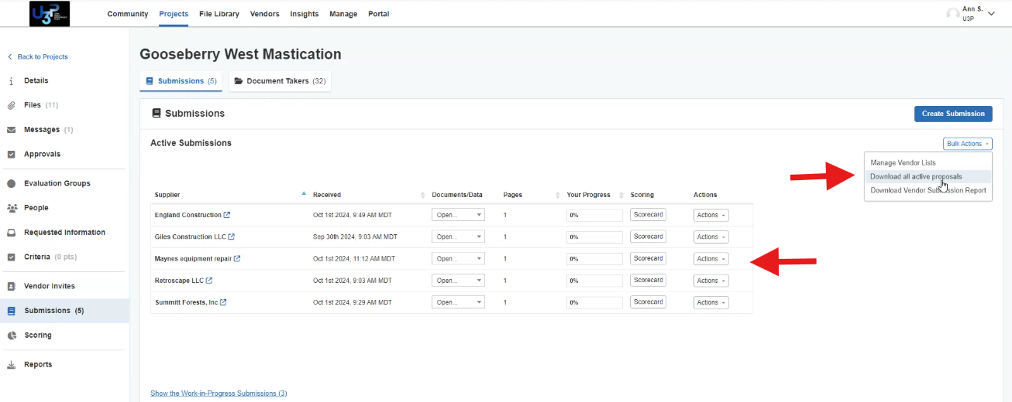**DOWNLOAD ALL PROPOSALS**

1. Select ***Submissions*** Tab
2. Click on ***Bulk Actions***
3. Select ***Download all active proposals***.

**DOWNLOAD ONE PROPOSAL**

1. Select ***Submissions*** Tab
2. Find the line for the desired **Supplier**
3. Click ***Actions*** (line specific)
4. Click ***Download*** in the drop-down list

**OPENING DOWNLOADS**

1. In Google, select the ***Download*** icon
2. Select the ***Zip file*** and drag to desired Google Drive Folder
3. 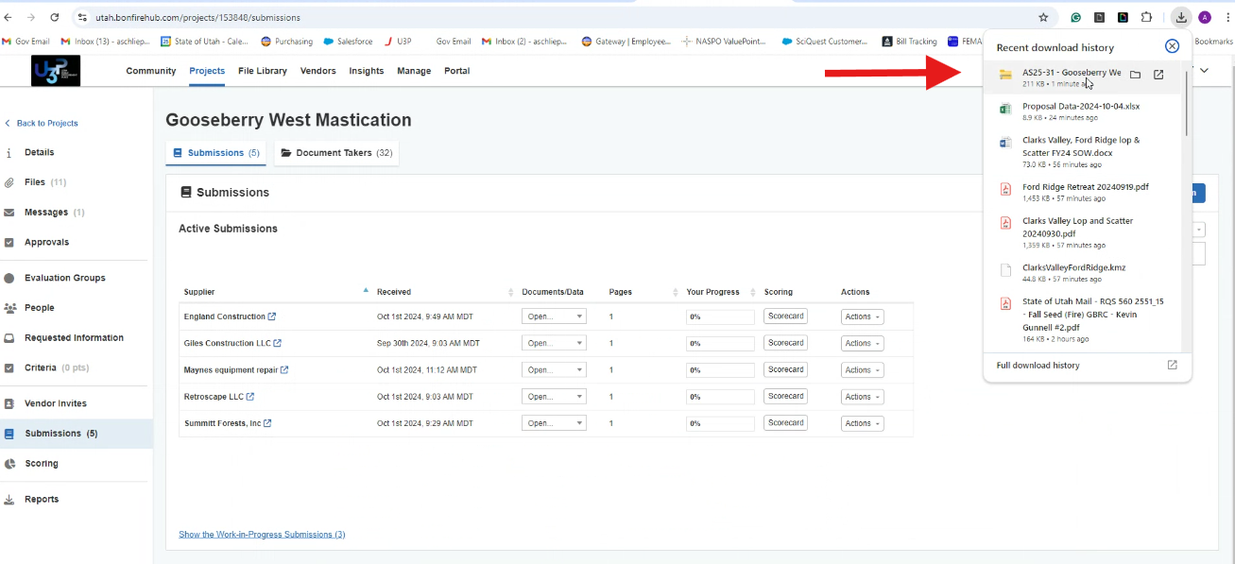Unzip by right clicking on the file, and selecting ***Extract All***

You now have what you need to review your solicitation or begin the evaluation process.

Awarding IFB or Quotes with a Bid Table–

*Skip to Step 4 for other solicitation types. *Skip to last page for Part 8

*Once your initial evaluation is complete and you are ready to award.*

1. 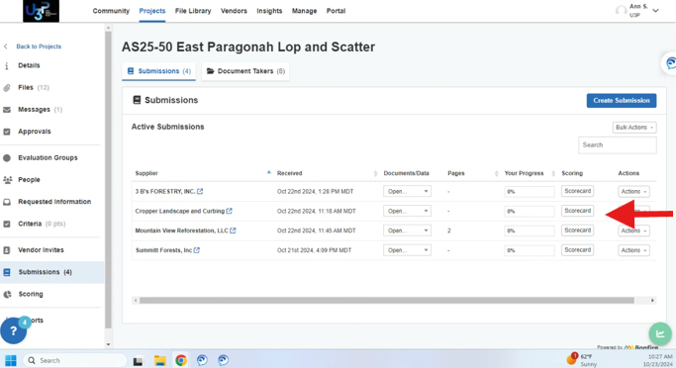**Open the Bid Table**
2. Select ***Submissions*** tab
3. Click on any ***Scorecard***
4. Click ***Score***
5. Click ***Order List***: ***Your Name***,
6. 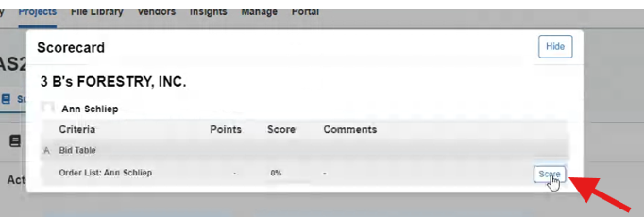Click ***View Order List*** button

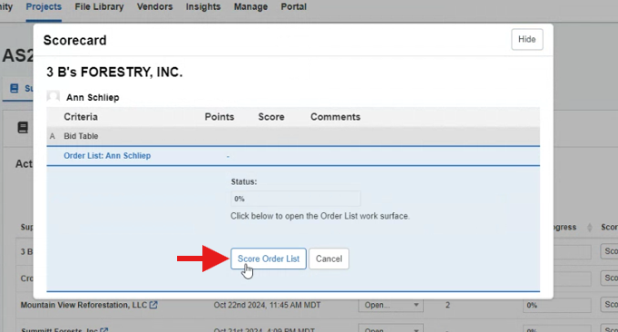

1. **Award by lowest total bid or line item**

Award to Lowest Bid (Total Cost)

*If your solicitation stated the award was by lowest total cost*

1. Click the ***Star*** under the vendor/supplier

**(Optional) To remove shading, click the World Icon**

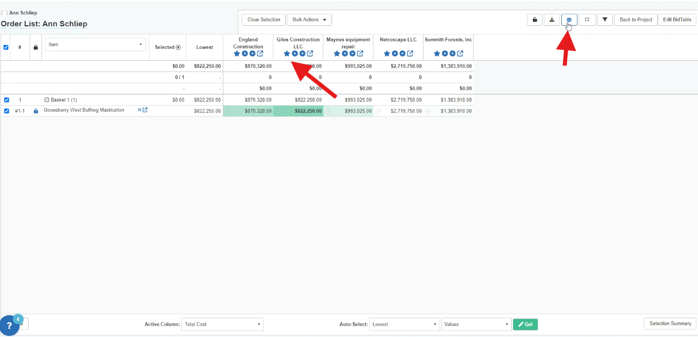

Awarding by Line Item

*If your solicitation stated the award was by lowest cost by item and NOT by lowest total cost*

1. Locate the winning bidder/supplier on the basket table’s first line/row
2. On line one, click the ***Target icon*** for the winning bidder/supplier

The ***Target icon*** will turn orange to signal the winner for that line/row

1. Repeat for each line.

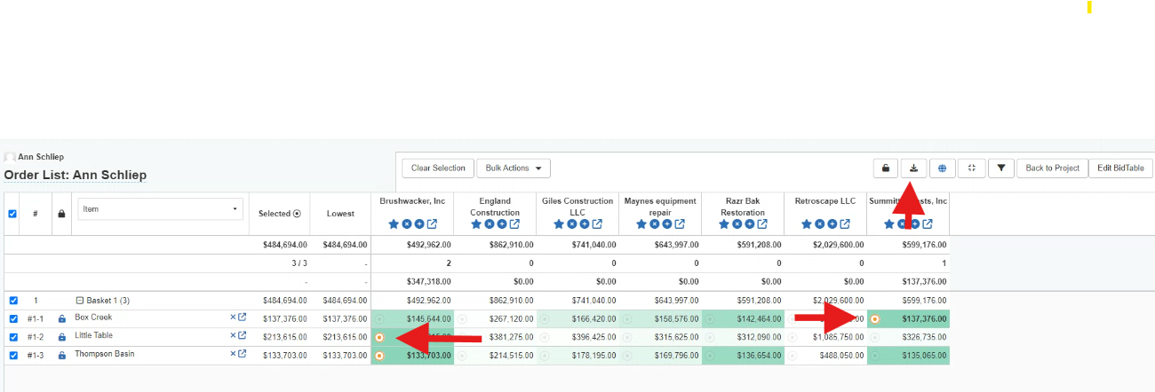

Steps for 2. a, b, c & 3. a

1. **Download Results**
2. Click on the ***Download button*** to export the BidTable to Excel.

This will be going out with your award, please view and format the Excel spreadsheet. If you are creating a PDF, view print preview to check fit to page width. For more than 4 vendors, consider landscape view.

1. **Awarding to Winning Vendor(s)**
2. Click on ***Back to Project*** to return to the project’s main page

On the Project’s page

1. Click ***Actions***
2. Select ***Mark as Completed*** (NOTE: You cannot award until you have Marked it as Completed)

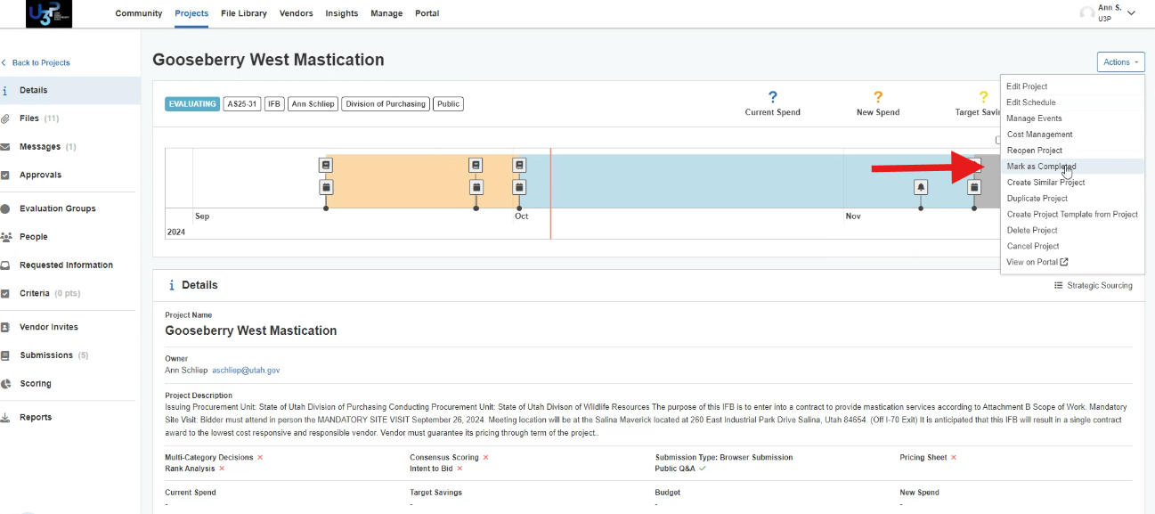

4. Steps a, b, & c

1. Click ***Submissions*** tab
2. Click ***Actions*** beside the awarded supplier name
3. Click ***Award***

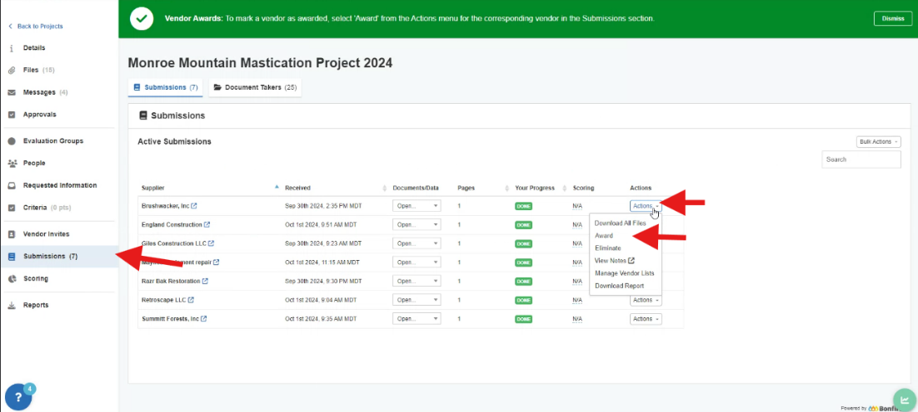

Steps 4. d, e, & f

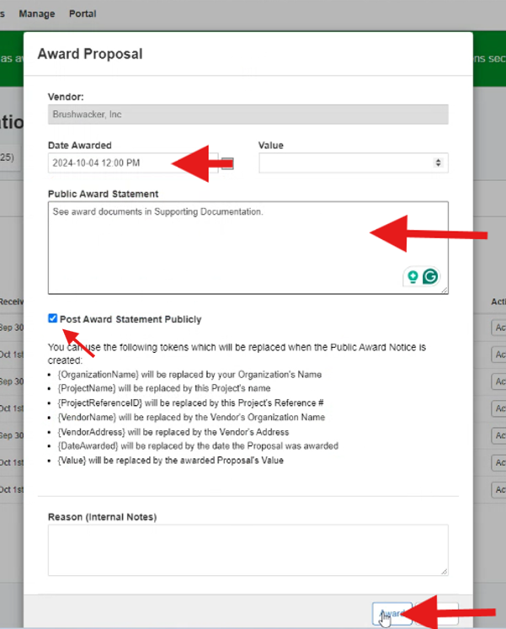**Award Proposal Screen** Pop Up

1. **Date Awarded**: Select date and time
2. **Public Award Statement**

Add wording similar to ‘See the award documents in the Supporting Documentation’

Ensure “Post Award Statement Publicly” box is checked

1. Click ***Award***

You will be returned to the project

For multiple award: repeat the steps from 4.

**Note: This does not send a notice to the vendors. It publishes the award to the public site. You must send a public notice to the vendors (see below).**

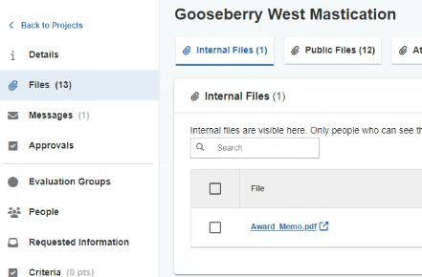

**a**

**b**

**c**

Steps 5. a, b, & c

1. **Sending a Public Notice of Award**
   1. Click ***Files*** tab
   2. Default is the ***Internal Files***
   3. Download ***Award Memo***
   4. Click ***Messages*** tab
   5. Click ***Public Notices***
   6. ***Subject***: Solicitation # Award
   7. ***Message***: Standard message can be “Please see the attached documents.”
   8. ***Attach file***: Attached the downloaded ***Award Memo*** (see 5c) AND your award documentation files
      1. The files attached are selected based on the requirements of the solicitation type: Justification Statement, Bid Table, Ranking, etc.
      2. The documents will be posted to the Supporting Documentation on the public portal automatically and immediately. The notice itself will be emailed at the top or bottom of the hour.

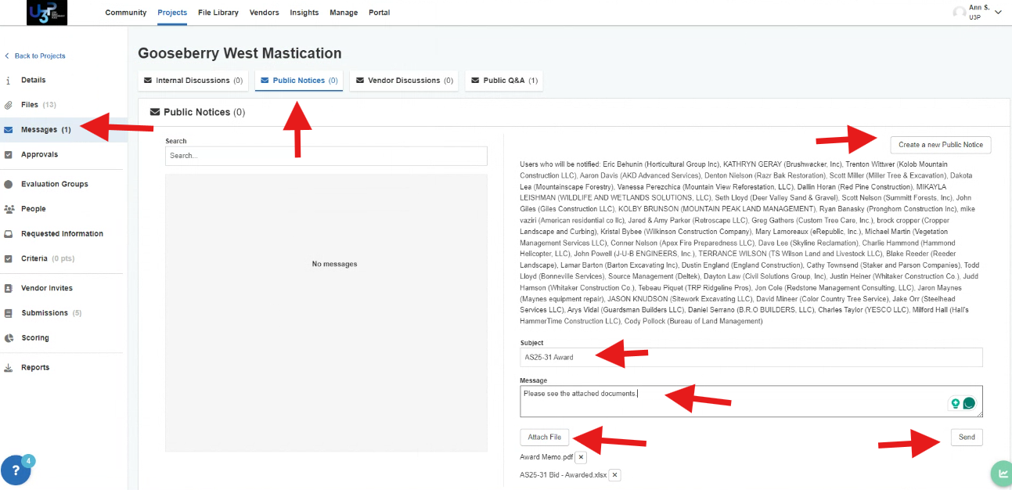

Steps 5. d, e, f, g, & h

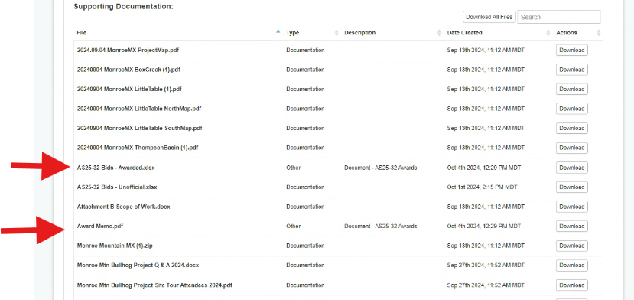

Public Portal View of Award Documentation

**You have awarded!**

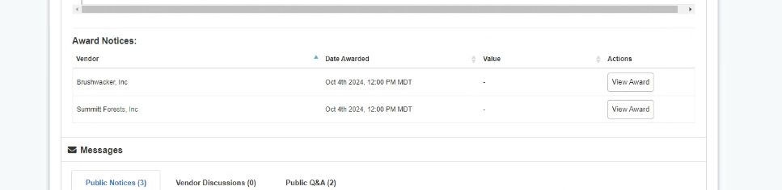

Public View of the Award

***Archive the project/solicitation*** once the Contract or PO is complete. Archiving does not impact the public view. It simply removes it from Active Projects. See the information below to see how to archive a project

***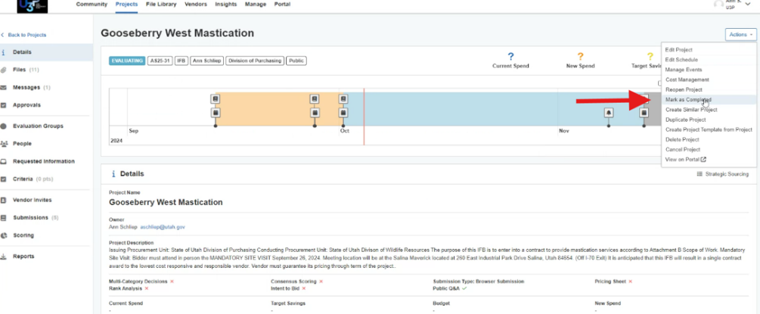*Part 8 Closing**

On the Project’s page

1. Click ***Actions***
2. Select ***Mark as Completed***
3. 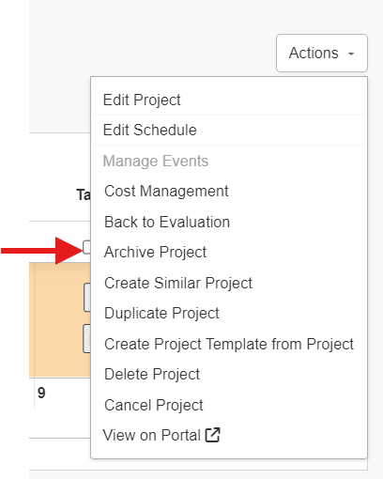Click ***Actions***
4. Select ***Archive Project***

The Notice of No Award is already in the public files.