**Extending or Amending a Bonfire Project**

In the instructions,***blue words*** direct you to a button, icon, or tab*.* ***Orange words*** are a field that requires input. **Green words** are a title or subtitle.

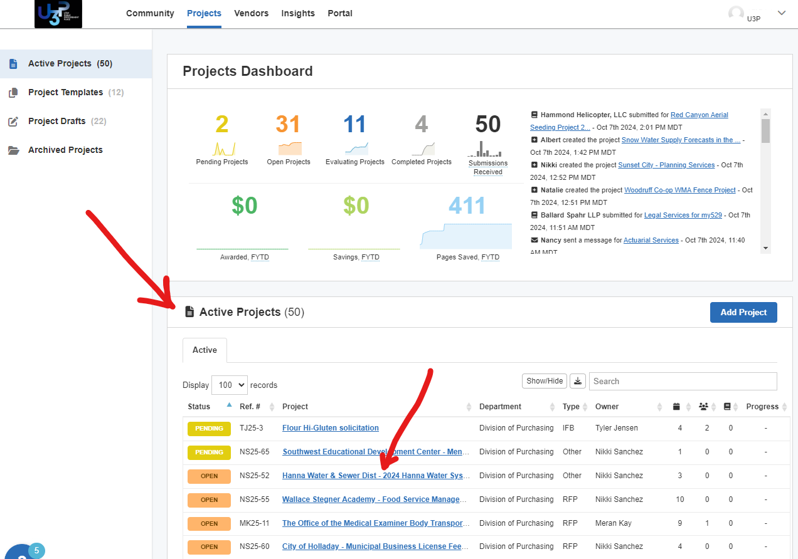Unlike Jaggaer, you do not need to click a specific button to amend. You can simply change the dates or add your updated files to the public files.

**FIND & OPEN THE PROJECT**

1. Go to the Home Screen (displayed)
2. Roll down to **Active Projects**
3. Click the ***hyperlink*** for any ***OPEN*** Project

**TO CHANGE DATES:**

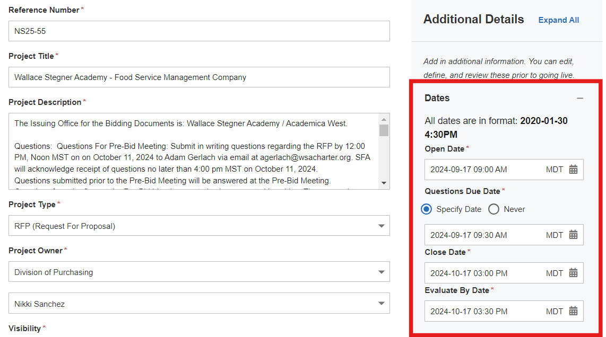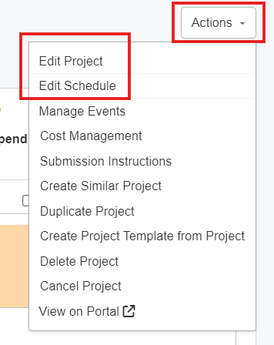Default is the **Details** Tab

1. Select ***Actions***
2. Select ***Edit Schedule*** or ***Edit Project*** and change your dates.
3. When completed, click ***Public Notice***
4. A banner appears across the top of your project to prompt you to send a Public Notice. Click on ***Notify Suppliers.*** 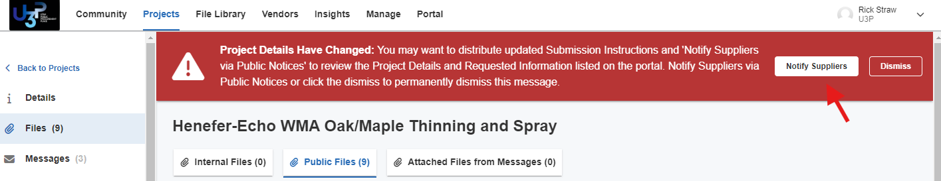
5. 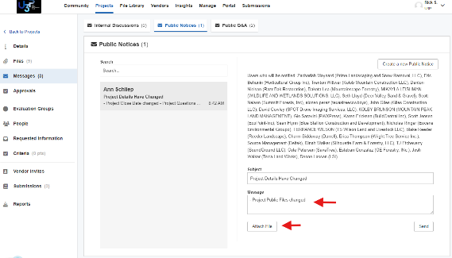You MUST send out a Public Notice because vendors do not receive an automatic email notification when you modify a date. The recipients and boilerplate language are automatically generated for you. Feel free to add any details you like to the message.

**TO ADD FILES TO A PROJECT**

1. Open the Project (see instructions above)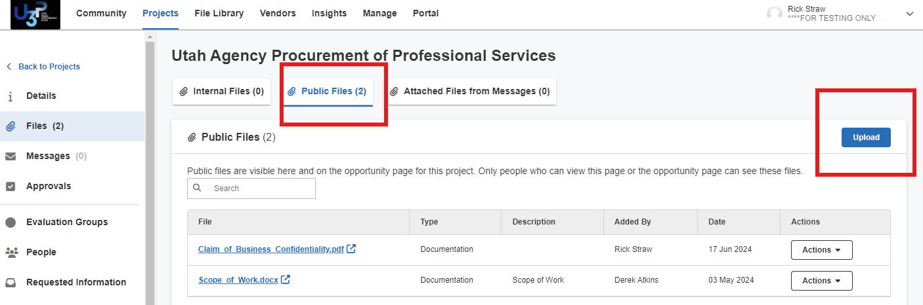
2. Select ***Files*** tab
3. Select ***Public Files*** button
4. Select ***Upload*** button

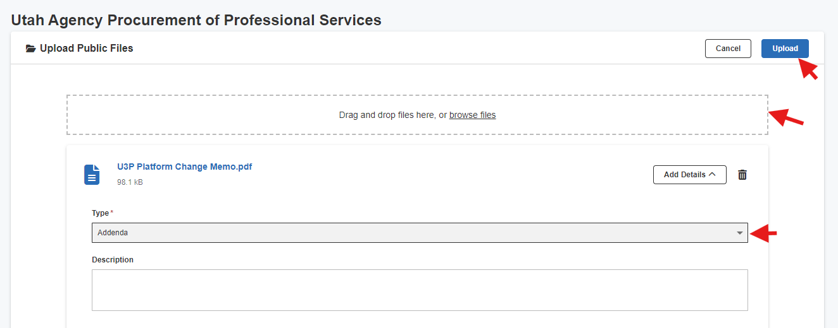

1. Label your new file appropriately i.e. “Updated SOW 10.11.2024”, “Revised Scoresheet 10.13.2024”
2. Drag and drop file
3. Select the **Type** of file
4. Click ***Upload***



When all files have been uploaded

1. Click ***Public Notice***
2. A banner appears across the top of your project to prompt you to send a Public Notice. Click on ***Notify Suppliers.***

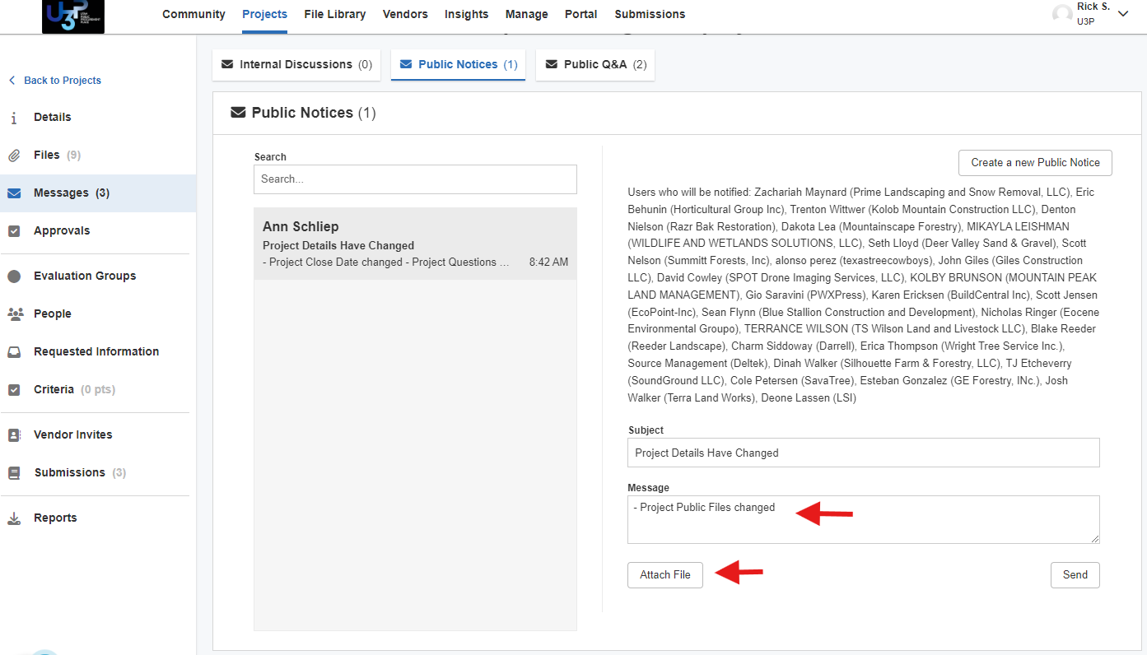

You MUST send out a Public Notice because vendors do not receive an automatic email notifications. The recipients and boilerplate language are automatically generated for you. Feel free to add any details you like to the message.

**Note**: Any file you attach to a Public Notice will automatically be added to the Public Files. It’s okay that they will be in there twice. We want the vendors to receive the new/revised document via email.