**Bonfire Posting and Cross Reference Instructions**

*In the instructions, all* ***blue*** *words direct you to a button, icon, or tab. All* ***orange*** *words direct you to a field.*

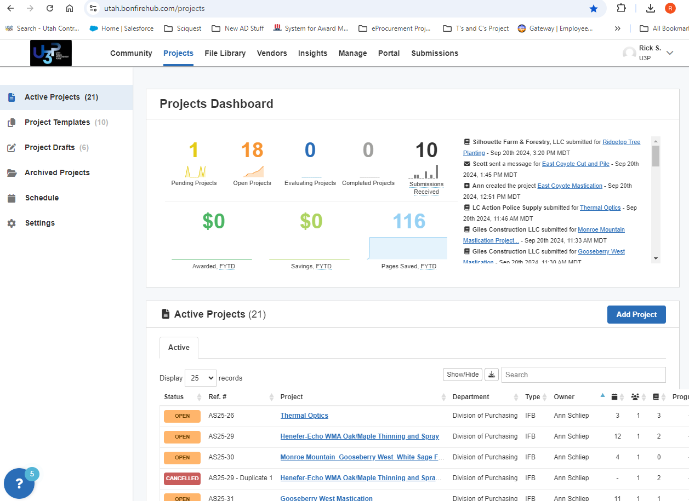HOME SCREEN

**OPTIONS**

1. Click **Add Project** to create a new solicitation.
2. Use the **Search box** to search for open solicitations by name or solicitation number.
3. The **”?”** icon opens the Resource Center. Use it to research any questions you have.

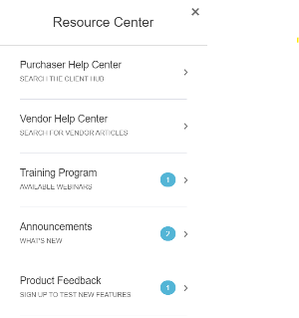

CREATE PROJECT DRAFT Window 1

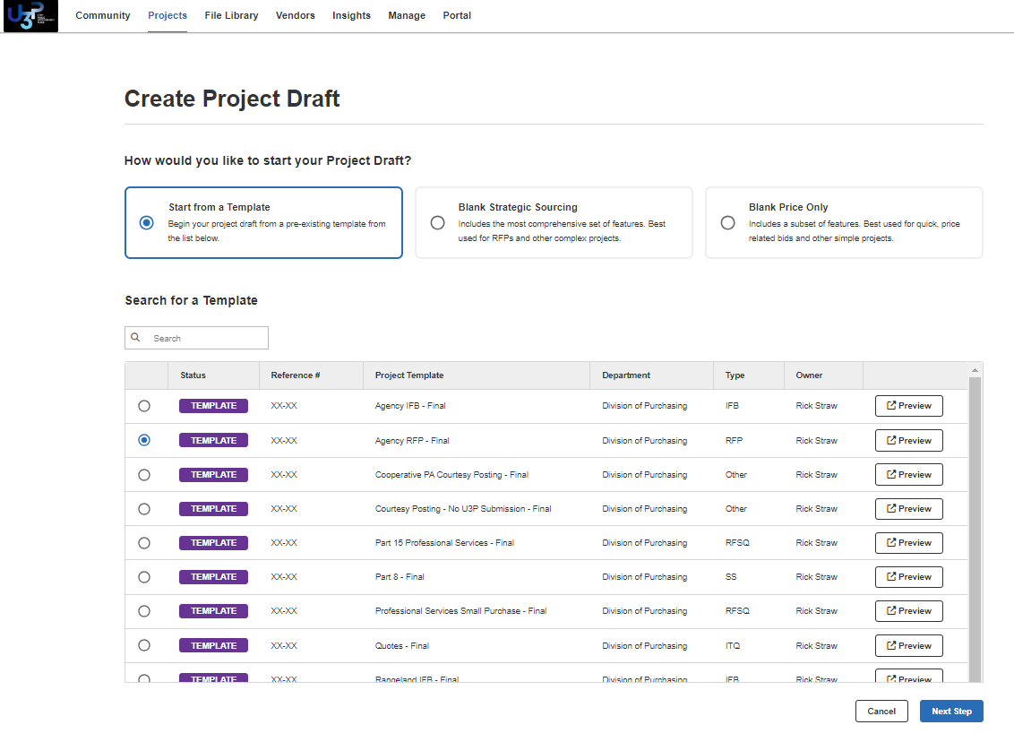After clicking Add Project, choose the applicable template.



CREATE PROJECT DRAFT Window 2

This page is a combination of the Jaggaer description and setup sections.

* **Reference Number**: add the Solicitation Number.
* **Project Title**: add the Title of your solicitation.
* **Project Description**: You must add input information in place of the underlining ‘ _____ ‘ AND delete information that does not apply. Example:
* **Project Type**: Field self-fills based on the template you selected
* **Project Owner**: Select ‘Division of Purchasing’ and enter your name.
* **Visibility**: Must always be ‘Public’
* **Dates**: Open, Question, Close, Evaluate. All must be entered.
  + Evaluate by date is not public and for your purposes only
* **Submission Types**: Do not modify
* **Configurations**: Do not modify
* **Contact Information**: - Enter your email and name
  + Leave on ‘Only Display AFTER the Questions Due Date’ unless your pod leader states otherwise

When all information is added, click **Create Project Draft**

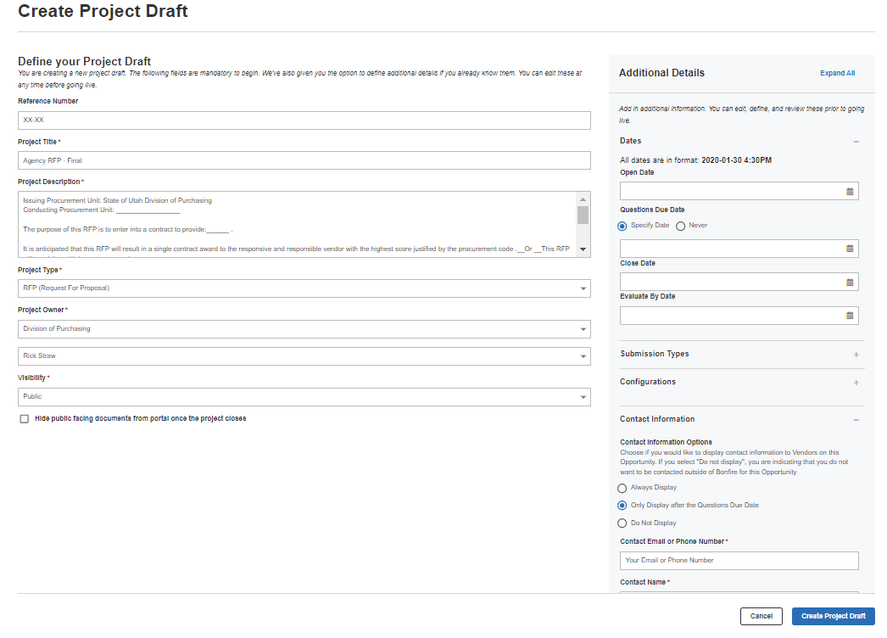

AGENCY RFP – FINAL

****DETAILS Tab****

* **Return to edit to your RFP**: Click **Actions** and **Edit Project Draft.**
* **View the project as a vendor**: Click **Actions** and **Preview on Portal.**  It will open in a new tab.
* **Obtain a URL for your solicitation**: Click **Actions** and **Preview on Portal.** It will open in a new tab. Follow the instructions in the box below.

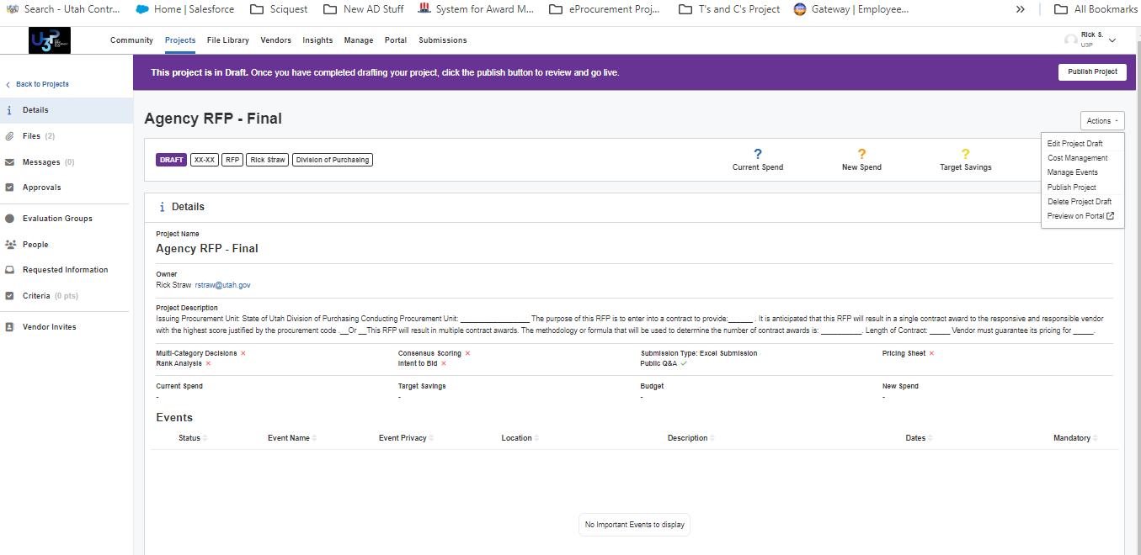



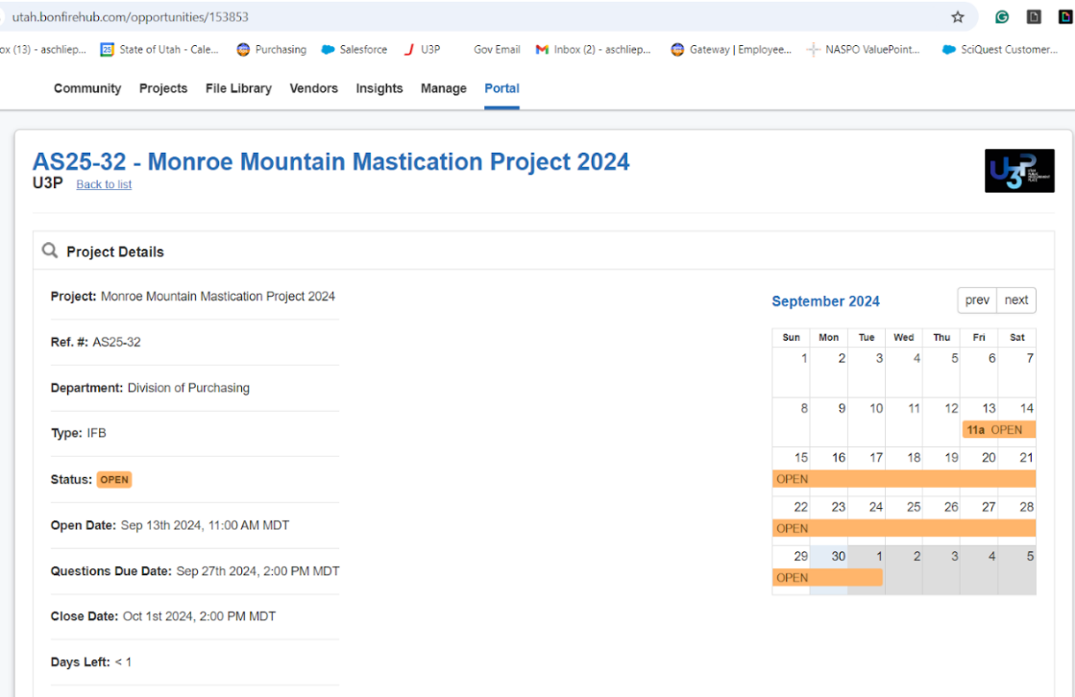

**Obtain a URL for your solicitation**:

Click **Actions** and **Preview on Portal.**

Copy the URL from the new tab to provide the direct link to your solicitation.

Purposes:

1. To paste in email inviting to vendors recommended by the agency to your solicitation
2. *Through at least the end of Dec 2025, agents must copy the URL and paste that URL in a Jaggaer solicitation.*

****FILES Tab****

This tab is for reviewing, adding, and removing solicitation files.

To access the files,

1. Click **Files** (#1)
2. Click **Public Files** (#2)
3. Remove unneeded documents
   1. If this is not an IT solicitation, remove the Attachment B T&C. Click **Actions** and **delete**
4. Add solicitation documents.
   1. Click **Upload** (#3) and add the documents specific to the solicitation (Agency specific T&C, etc.)
   2. If this is not an IT solicitation, remove the Attachment B T&C

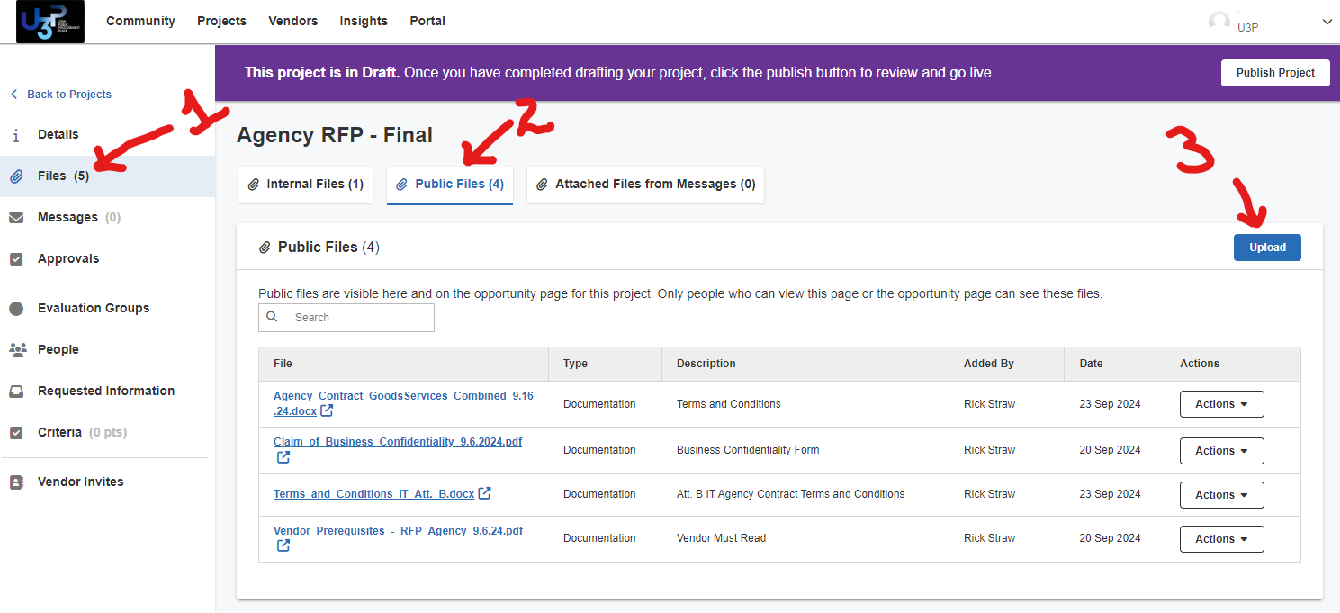

****APPROVALS Tab****

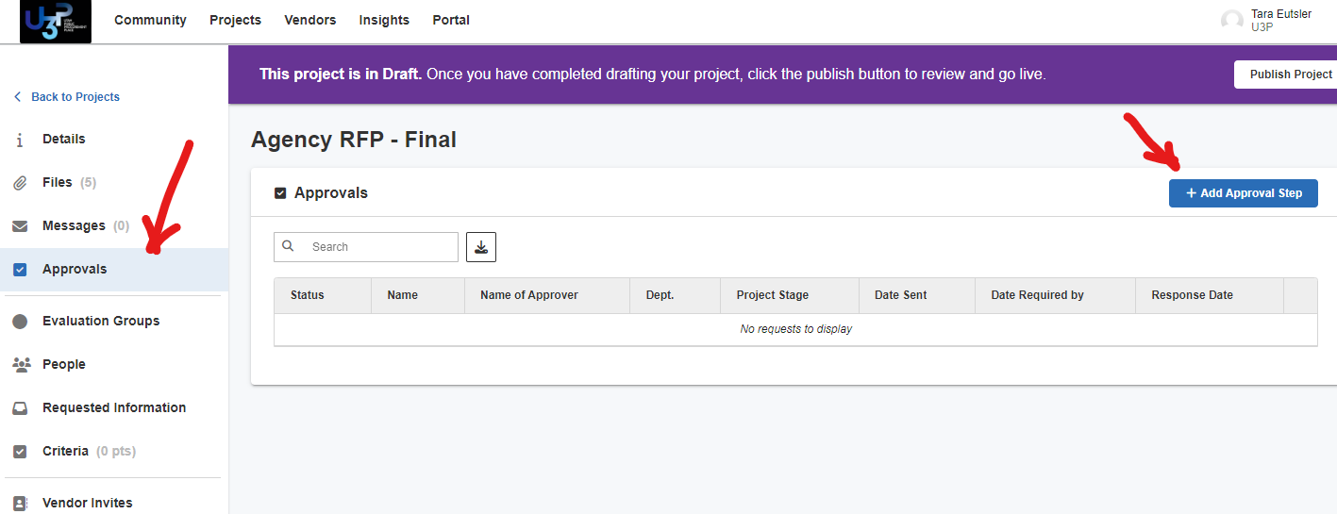Not required by Bonfire.

If you did not need approval in Jaggaer, it is not needed here.

New employees should ask the pod leader if an approval path is required and for which solicitation types.

****EVALUATION GROUP Tab****

The Division is not using this section at this time.

****PEOPLE Tab****

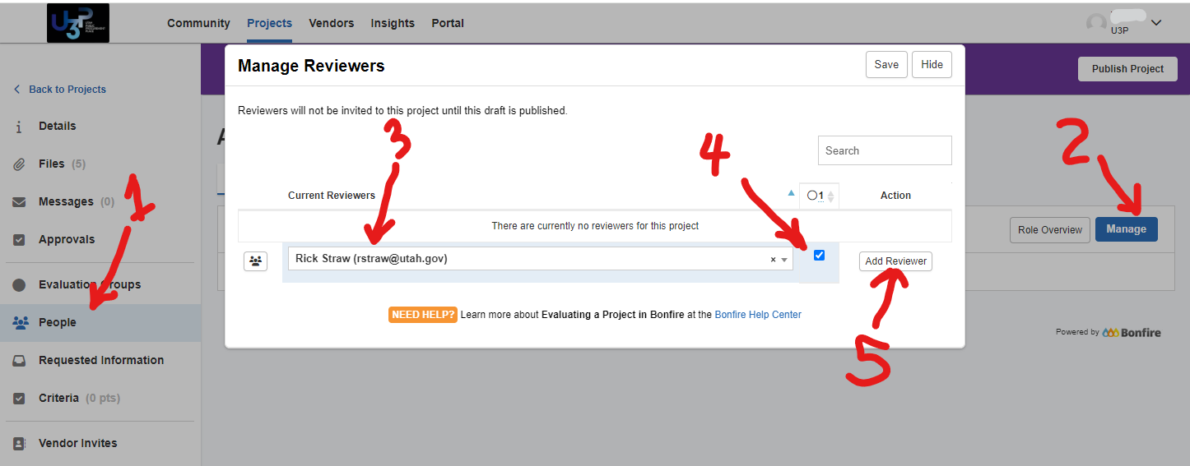

The list numbers correlate to the picture numbers.

You must add yourself as a Reviewer. If you will be out of town, add the pod member that will back you up.

1. Click **People**
2. Click **Manage**
3. Add yourself
4. Click the **checkbox**
5. Click **Add Reviewer**

Click **Save**

****REQUESTED INFORMATION Tab****

Tab to add, modify, or remove questions. Tab to create cost line items. You **must** modify or delete the first 4 placeholder rows of **Mandatory Minimum** or **Technical Criteria/Requirements**.

1. Click **Requested Information** tab
2. **To MODIFY or DELETE** the 4 placeholder rows,
   1. Click **Manage**

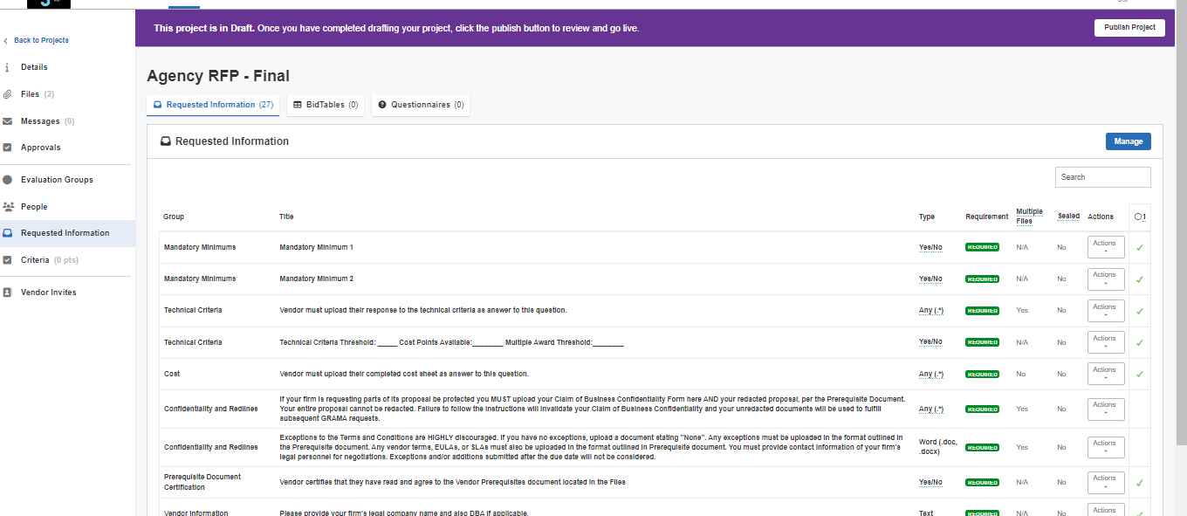

* 1. 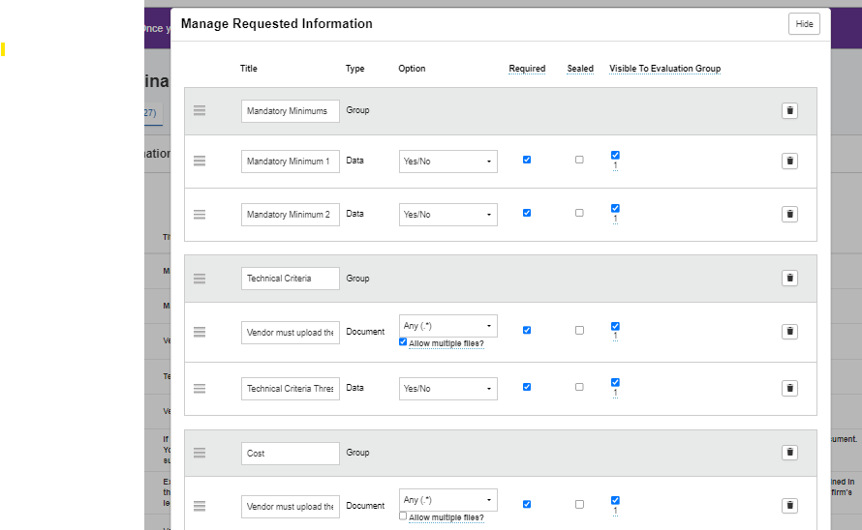Modify the Mandatory Minimum or Technical Requirements placeholder questions to match your solicitation needs

These rows are only placeholders and must be edited or delete.

Do not modify the other lines.

1. **To ADD** additional questions or document requests:
   1. 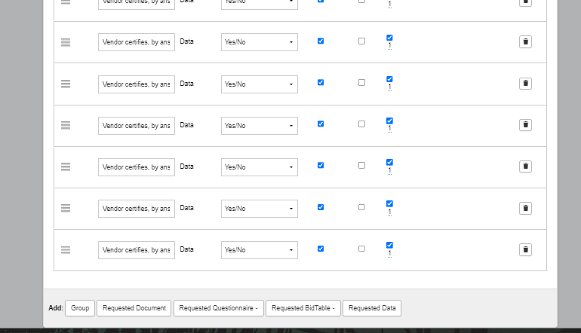Click **Manage** (may already have selected this)
   2. Scroll to the bottom of the interface
   3. Click **Requested Document** to ask the vendor for a document
   4. Click **Requested Data** to create a yes/no or text input field
   5. Go to the top of the page to see new data slots.
   6. 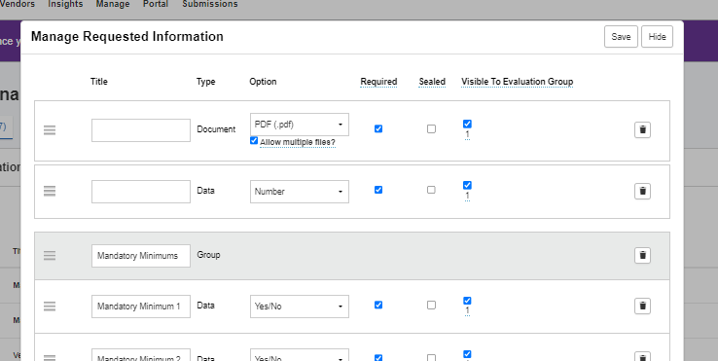Input your text and choose the options.
   7. ALWAYS click on the box “1”

If left unchecked, it will NOT be visible when your solicitation closes

The “1” controls who sees the document if the evaluation is conducted in U3P

****VENDOR INVITE Tab****

Tab where you add commodities and invite vendors.

**Note: You still MUST send incumbent vendors an invite from your personal email in addition to the below steps.**

NOTE: Codes come in four 2-digit multiple *segments*. If you pick “11’ for your first *Segment* and don’t select any other *segment*, any vendor registered for any child commodity code that starts with 11 will be notified. Do not feel the need to fill more than 2 segments.

Click **blue arrow** - (follow green arrow) Opens children commodity codes under a parent segment.

**To ADD Commodity Codes**:

1. Click **Commodity Code** (may already be in it)
2. Use **Keyword** field to search
3. 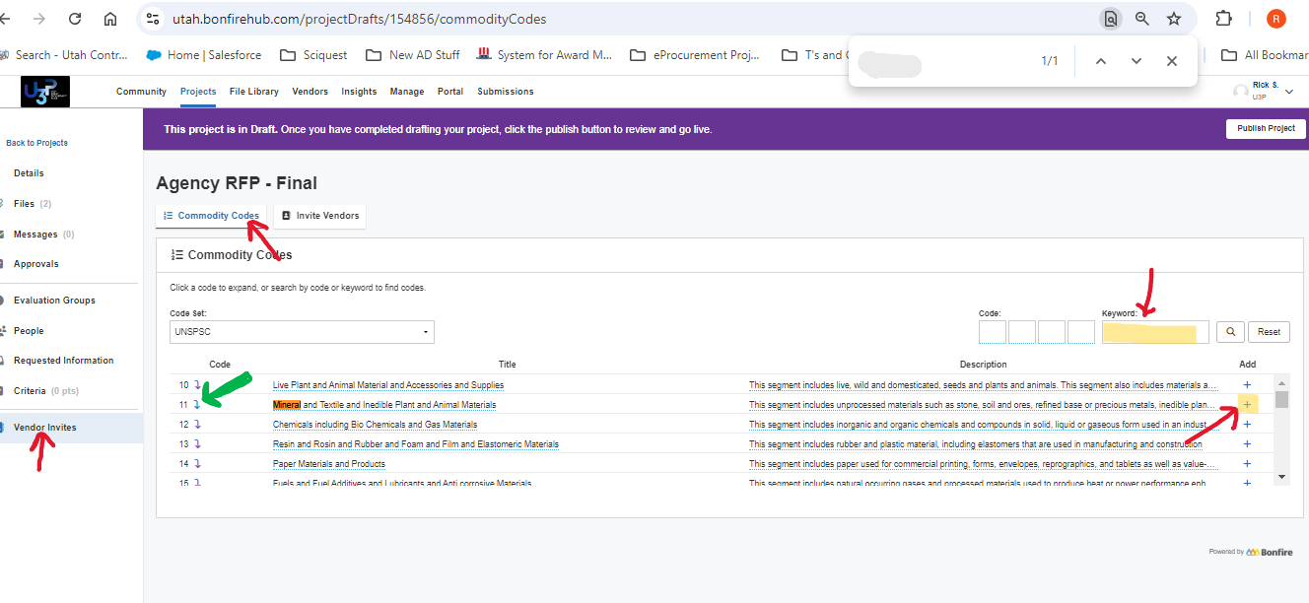Click **Plus sign** to the right of the code to add it
4. Continue the process until you have added all desired commodities. Warning this can be a rabbit hole. Avoid that!

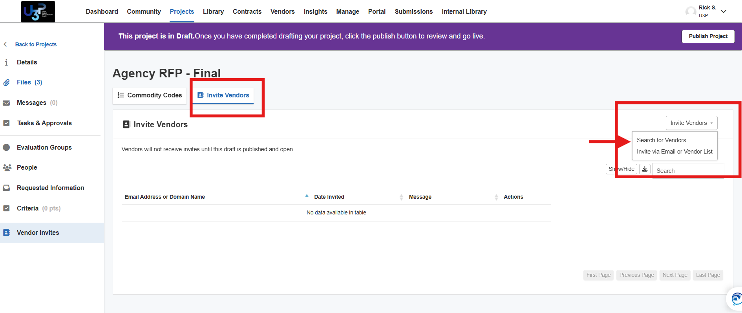**To ADD Vendors**:

1. Click **Invite Vendors** button on the left
2. Then click the**Invite Vendors** on the right hand drop down and select **Search for Vendors**.
3. You now have a list of vendors populated by the commodity codes you selected. Click the **top checkbox** next to the word **Vendor** to select all of the codes. Then click **Bulk Actions** drop-down and click **Invite to Project.**

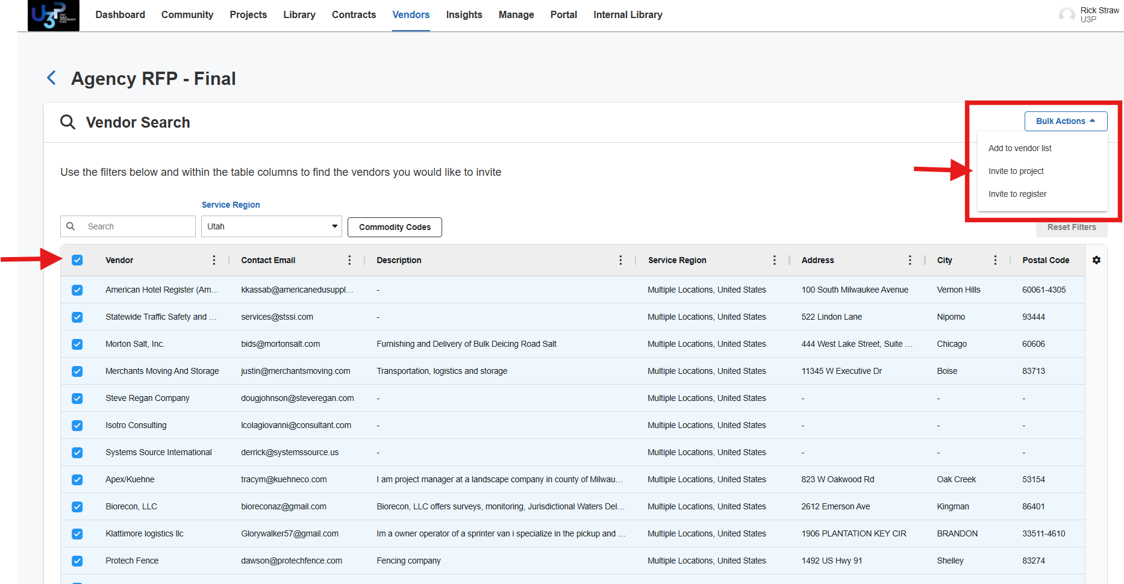

1. 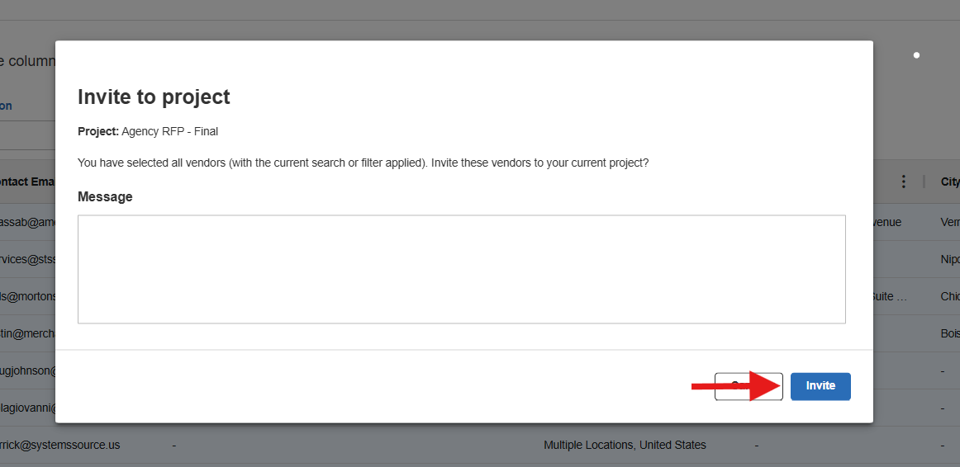If you choose, add or update **Message**. The vendors will receive a standard message similar to what they receive in Jaggaer now.
2. Click **Invite.** The vendors will be notified when the solicitation is published.

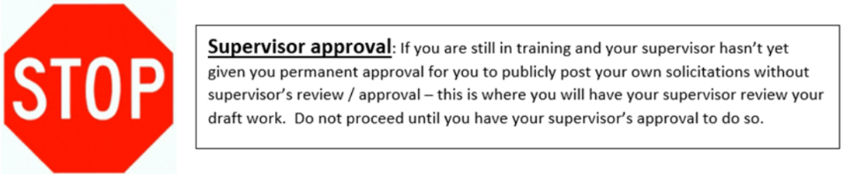

****REVIEW & PUBLISH****

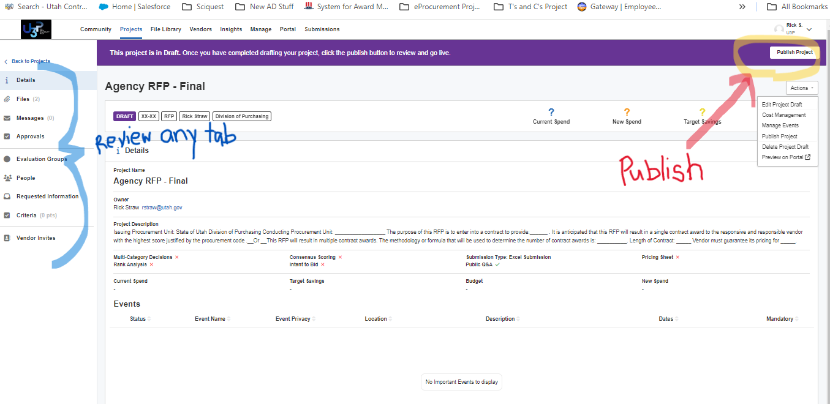You CAN review each tab by selecting the tabs on the left column

Return to **Details tab** to get the URL for your Jabbaer cross-tab publication (see page 1)

**To PUBLISH:**

1. 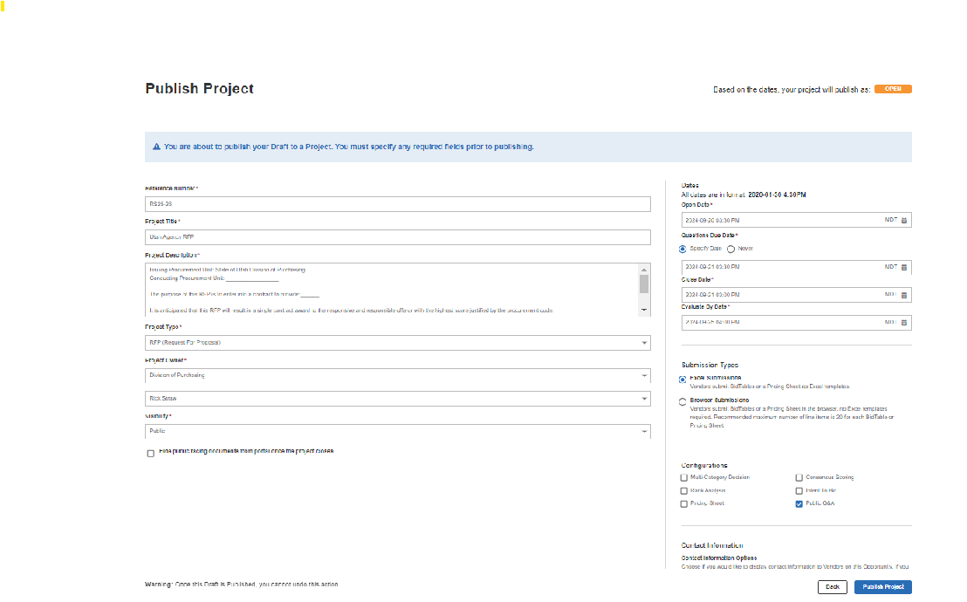Click **Publish Project** in the top banner on any tab
2. If you are not already on the **DETAILS** tab, you will be returned there.
3. In new window, click **Publish Project** on the bottom right
4. The project will show as **Open** with an orange box around it.

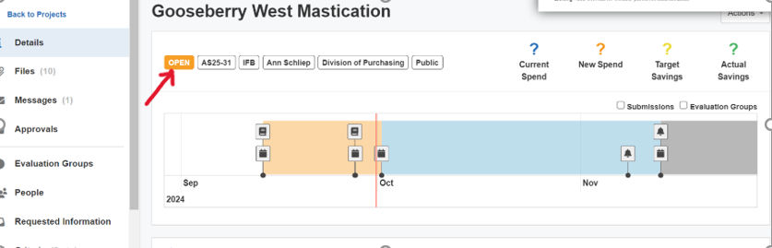

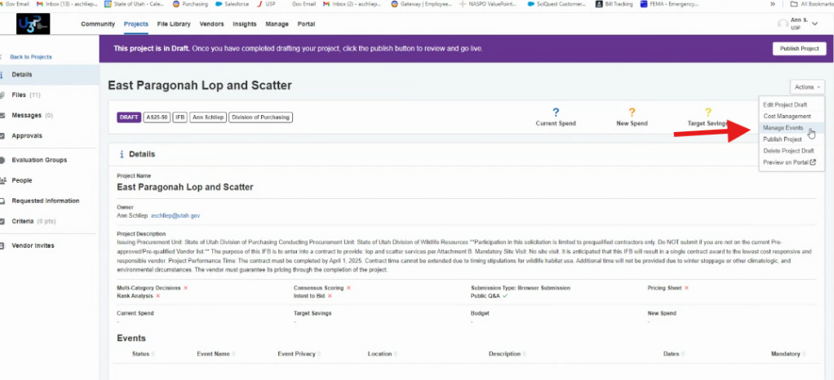****Adding a Site Visit or Prebid Meeting****

1. Click **Actions -> Manage Events** in the top banner on any tab
2. 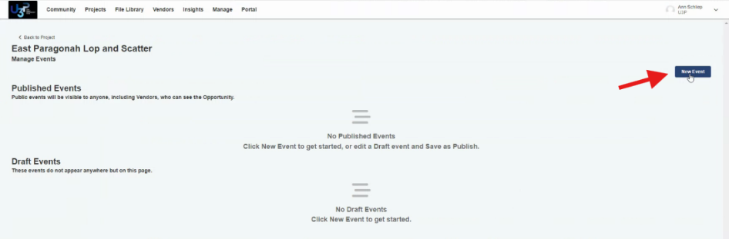Click **New Event** in the top banner on any tab
3. 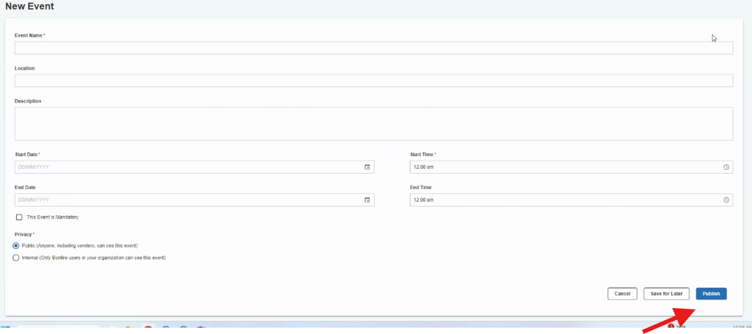Fill in the relevant details and hit **Publish.**
4. The event is added to your Project Page and the vendor page (click View on Portal under Actions to see)
5. If you are having a virtual meeting you can add the hyperlink in the Custom Fields drop down (click Actions -> Edit Project Details.

