Contract Amendments in
Total Contract Management

Step By Step Instruction for Public Entities

Provided by:
For Questions Contact – sciquestadmin@utah.gov
- Find your contract by selecting Contracts on the left, then searching for your contract number in the Type to Search Contracts box. 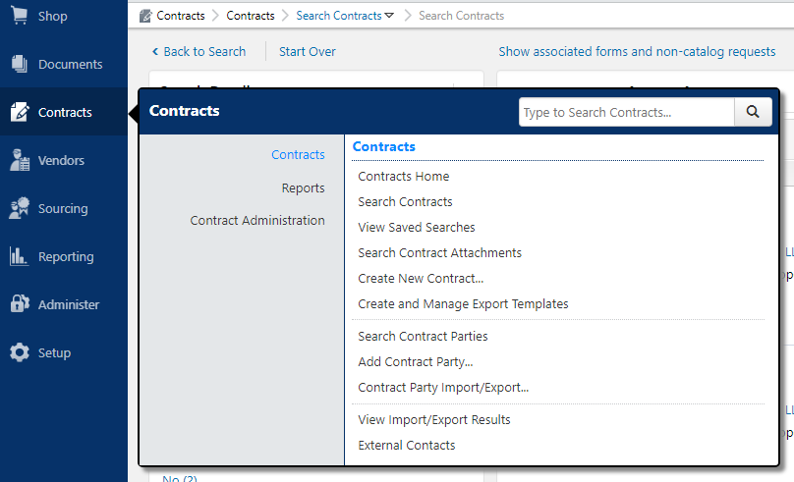
- You should now be able to view the contract. If you do not have the contract checked in, do so by going to Contract Actions, then Check In. Make sure your contract is in Executed: In Effect status. Go to Contract Actions, Amend. 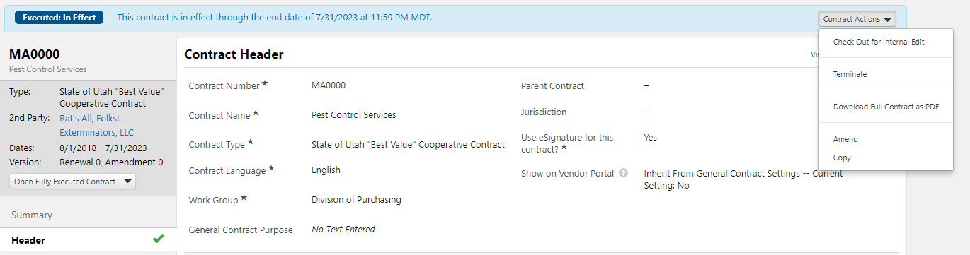

- The Amend Contract pop-up window will appear. As indicated below, the amendment will replace your contract, with the same contract number and type. Indicate whether you want the attachments from your contract to carry over into the amendment by selecting the appropriate “yes,” or “no,” radio button. Then select Yes to proceed with your amendment.
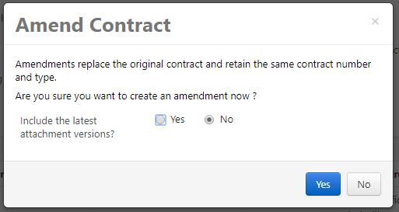
- The contract header of the amendment opens, containing information copied from the previous contract and from the contract template if one is selected. The Contract Number and Contract Type fields are locked and cannot be changed. The color of the bar at the top of the page has changed color and the Actions button is now "Amendment Actions".
  - This is where you can delete the amendment if it was created by mistake.
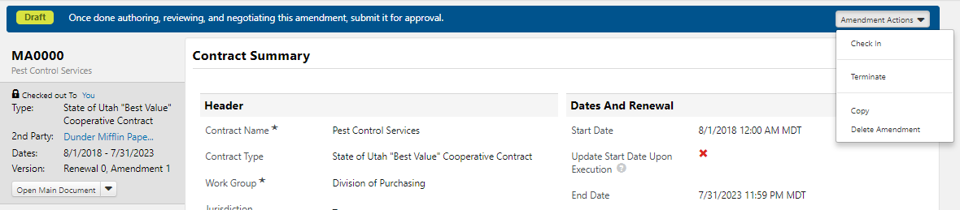
- Make changes to the editable contract header fields as needed. Ensure to save changes.
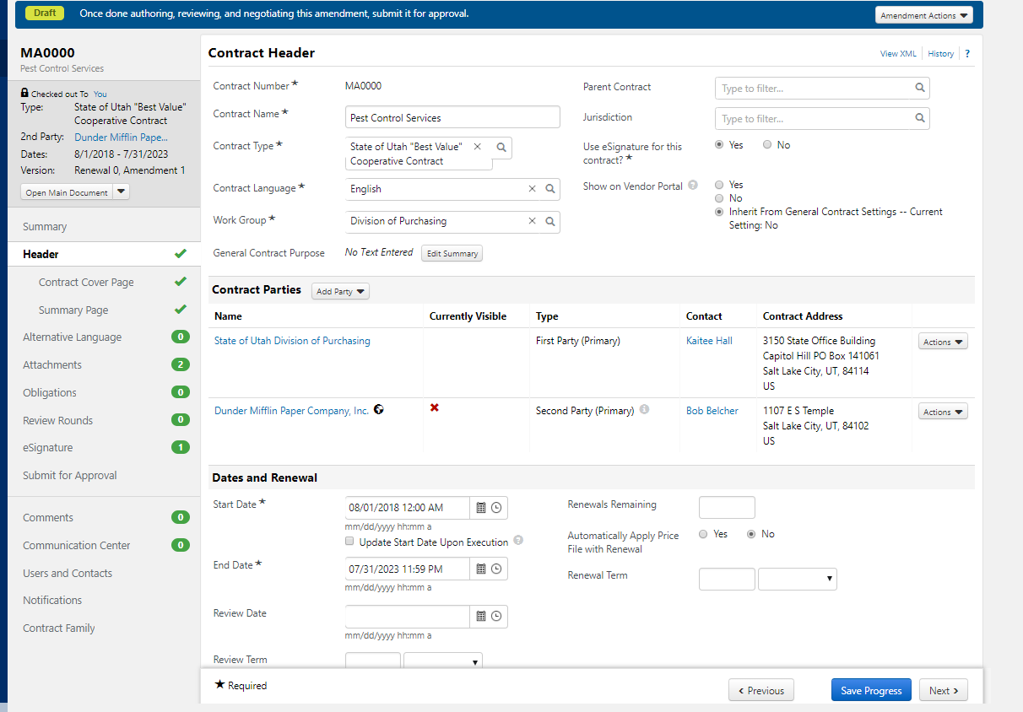
- Upload your new amendment documents to the Attachments section.
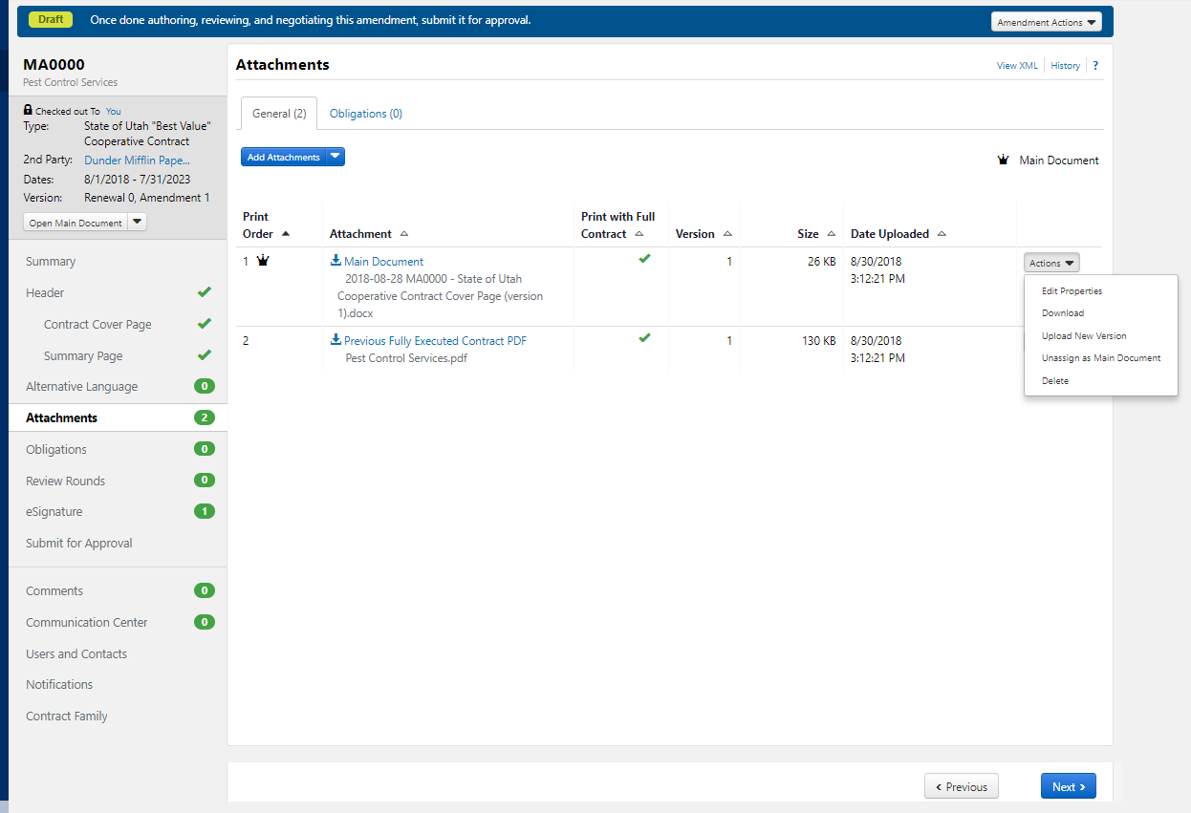
- Click Next.
- Make changes to additional contract sections as needed.
- Once changes are complete and correct, click Submit for Approval to release the contract amendment into the contract approval workflow. 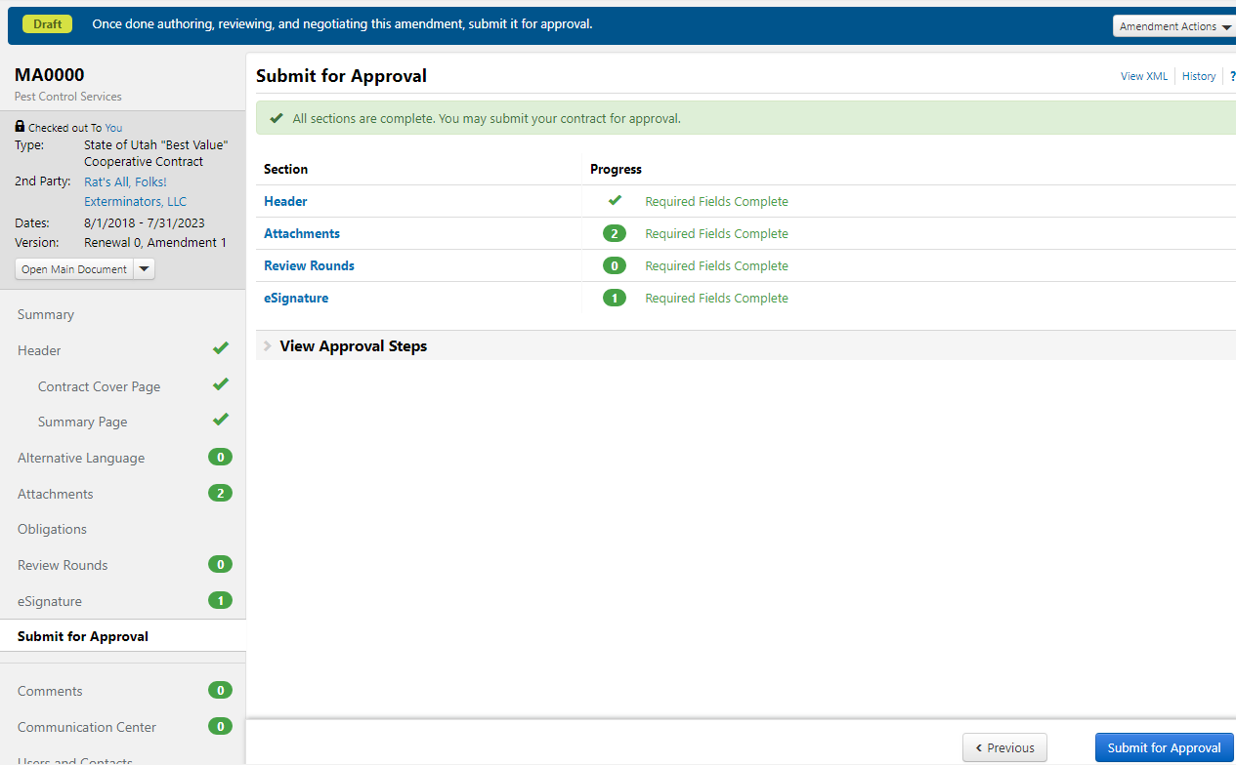
- You may view prior amendments to your contact by selecting Contract Family.
  - Here you see there are 13 amendments with the latest amendment still in a Draft status.
  - To view any one amendment select the i icon just to the right of the Version Type column.
