Review Rounds Process in
Total Contract Management

Step By Step Instruction for Public Entities

Provided by:
For Questions Contact – sciquestadmin@utah.gov

- To begin internal and external review rounds for your contract, first select Review Rounds on the left side panel for the contract you would like reviewed. Then you may begin either an internal or an external review round.
  - Create an Internal Review Round to have your contract reviewed by those internal to your organization.
  - Create an External Review Round to have your contract reviewed by those external to your organization. I.e., this is where you’d have your Contracted vendor review the contract.
  - When a contract is under a Review Round, it cannot be edited by the Contract Owner.

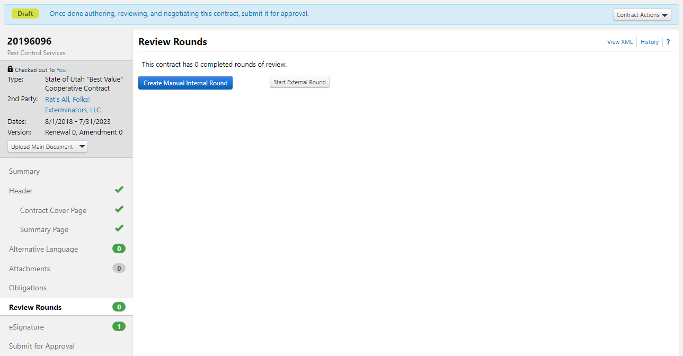

- When you select Start External Round, the system will populate the following screen, requesting that you add a reviewer, or delete the round entirely. To add the reviewer, select Add Reviewer.
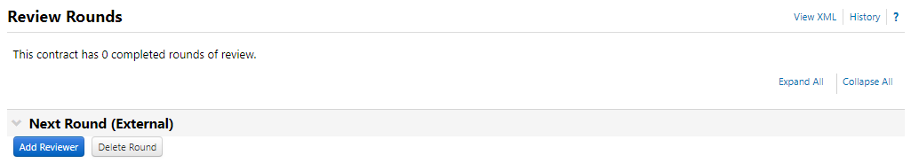

- Complete the required/starred fields from the Add Reviewer pop-up screen and hit Save. 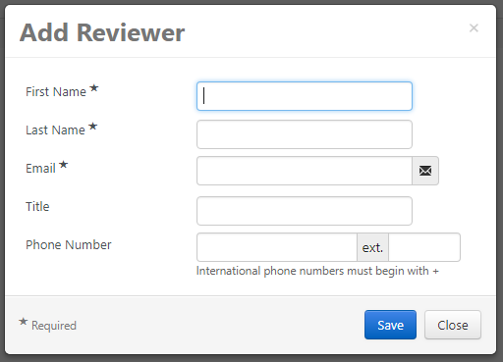
- You will then be able to view the vendor contact information that you have entered. If any of it is incorrect, you may edit it by selecting Edit Properties. If you are ready to kick off the review round, select Begin Round.
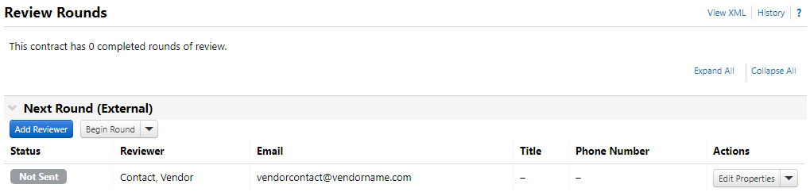

- Beginning the review round will take you to the following screen, where you may select the recipient and attachment, as well as edit the email that will be sent to the reviewing vendor. Then you may select Send Email for the review to be sent to the appropriate reviewer(s).
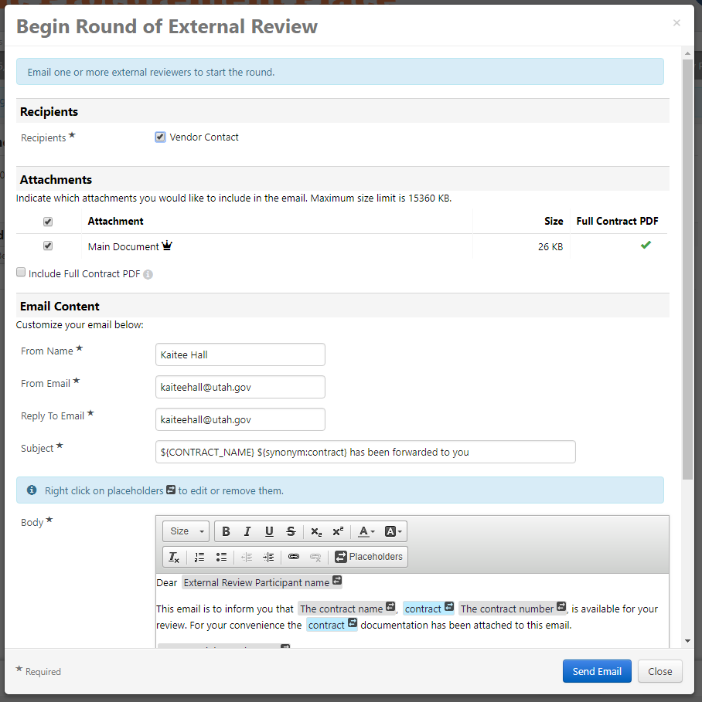
- If you have successfully sent the email to the vendor, the Review Rounds screen will change to look like the image below.
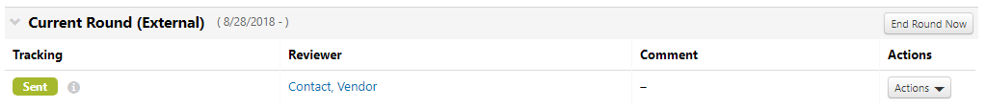
- If the vendor responds to your email, the email will be sent to you directly, as well as being logged with the Communication Center within the TCM contract. All correspondence between the reviewers and yourself will be stored here. Click the message icon to view more details. 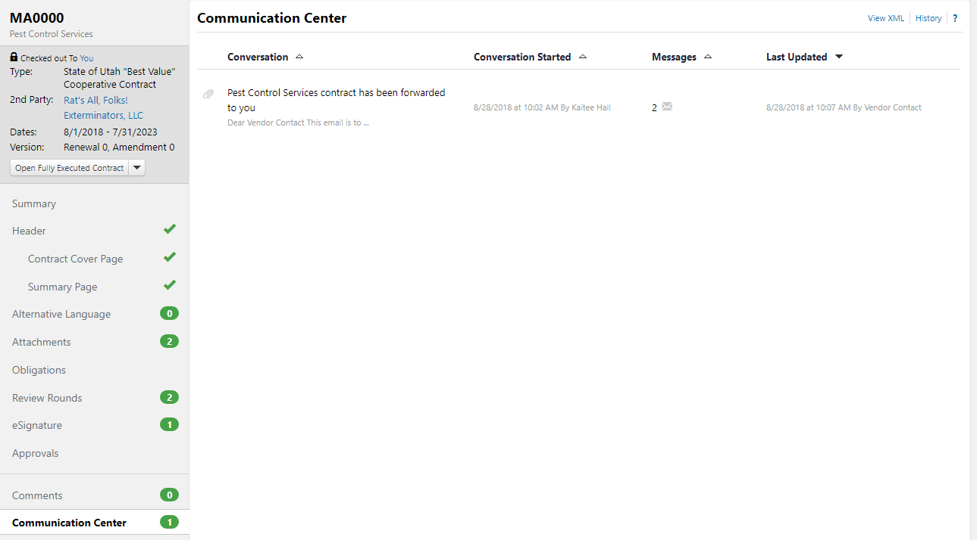
- Below you can see what is stored within individual “conversations” with reviewers. You may see herein the vendor’s email response to the contract they have reviewed. These comments will also be sent to you directly via email.
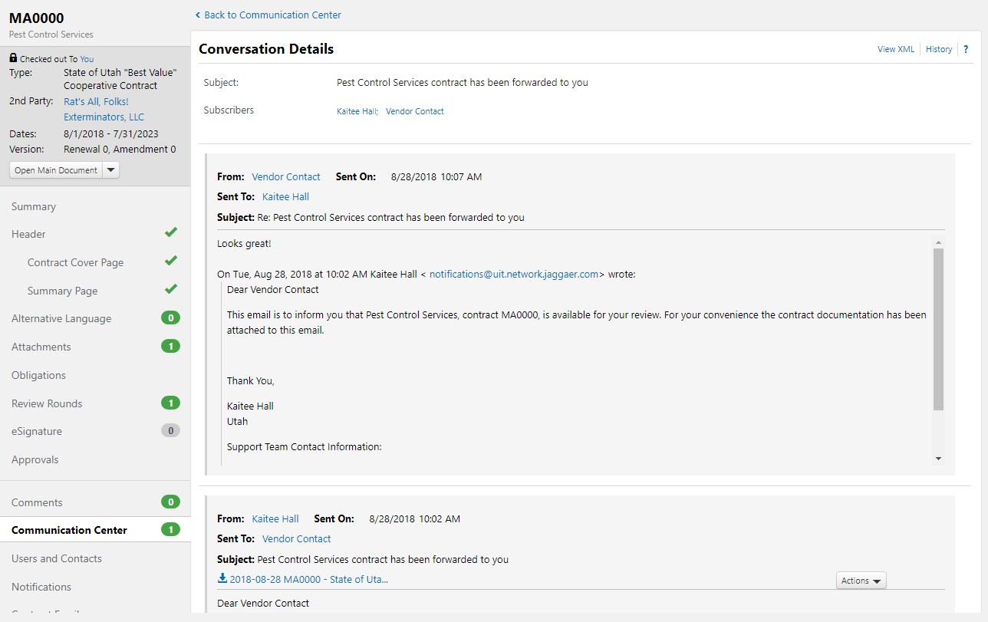

- Once the vendor review has been completed, go back into the Review Rounds section of your contract, select the Actions dropdown, and then Done with Review. 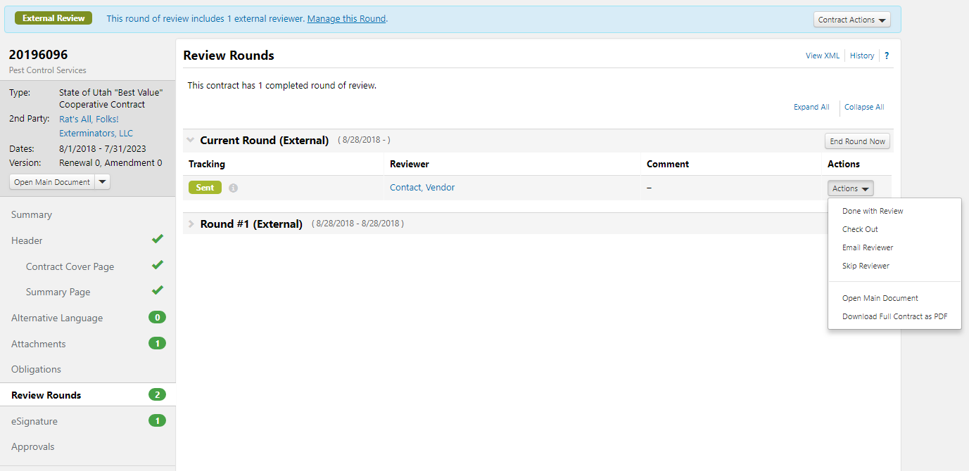

- Enter a review comment and hit Done with Review. 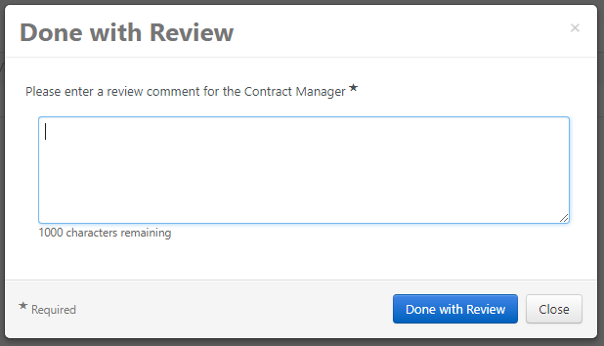

- You will be able to tell the external review is completed when your Review Rounds screen looks like the screenshot below. From this screen, you will Create Manual Internal Round. 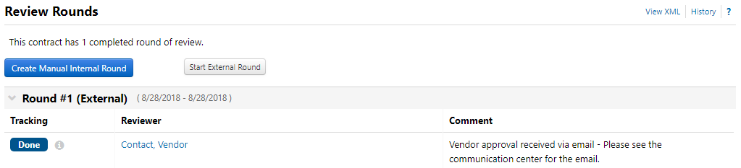
- Select Add Reviewer. 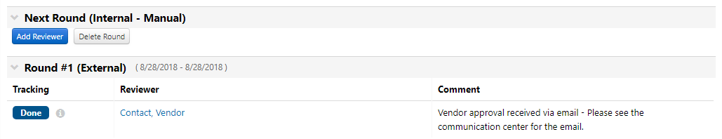
- The User Search pop-up will appear. You may search (by first or last name) for the member of your organization that you would like to review your contract. Then Select and Save Changes.

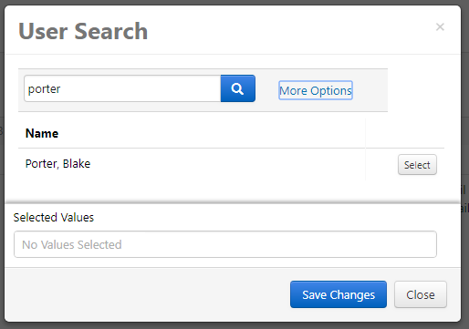

- Begin Round. This will send the reviewing individual an email that will allow them to review the contract. 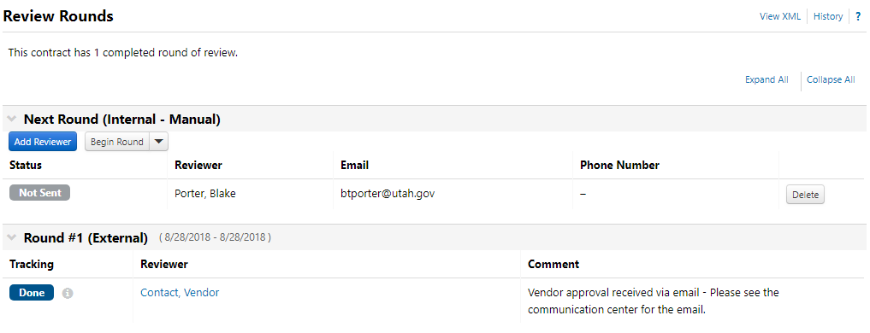
- The Begin Internal Review pop-up appears, with an optional message field. You may use this field to send a message to your reviewer. Select the blue Begin Internal Review button.
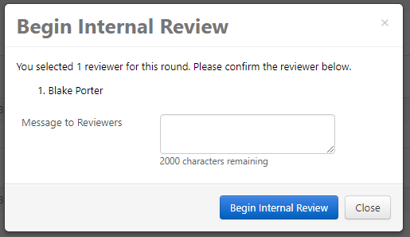
- The reviewer will be able to go into your contract through the Jaggaer/Sciquest system and view it. After they have conducted their review, either you or the reviewer themselves may complete the review round by going to Actions, then Done with My Review in the Review Rounds section of the contract.
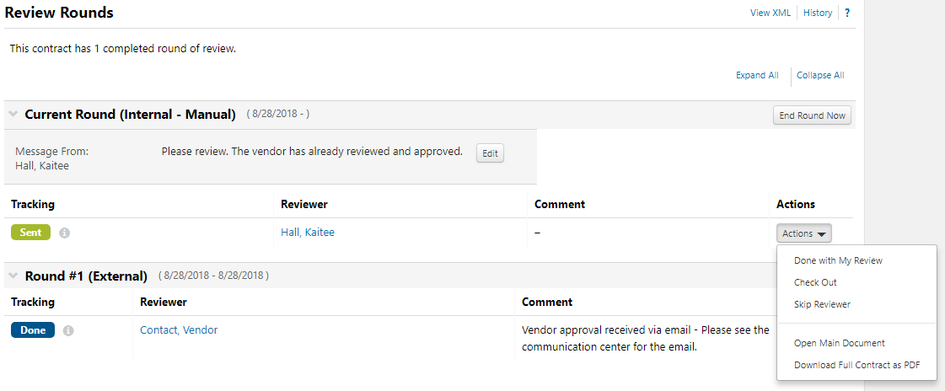

- The individual closing out the review provides a review comment for the Contract Manager, then selects Done with My Review.
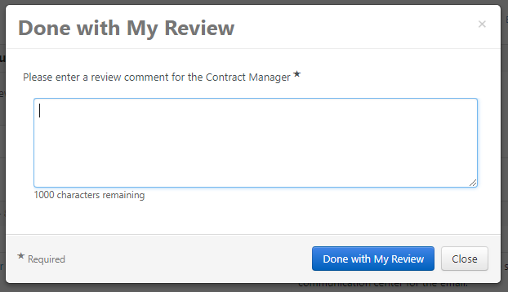

- Once both internal and external rounds are completed, the reviewers and related comments will be viewable under the Review Rounds section of the contract.
