Developing Your Contract in
Total Contract Management

Step By Step Instruction for Public Entities

Provided by:
For Questions Contact – sciquestadmin@utah.gov

- Open your awarded Sourcing Event. Navigate to the Vendor Responses pane > Select Evaluation Actions > Evaluate All Responses.
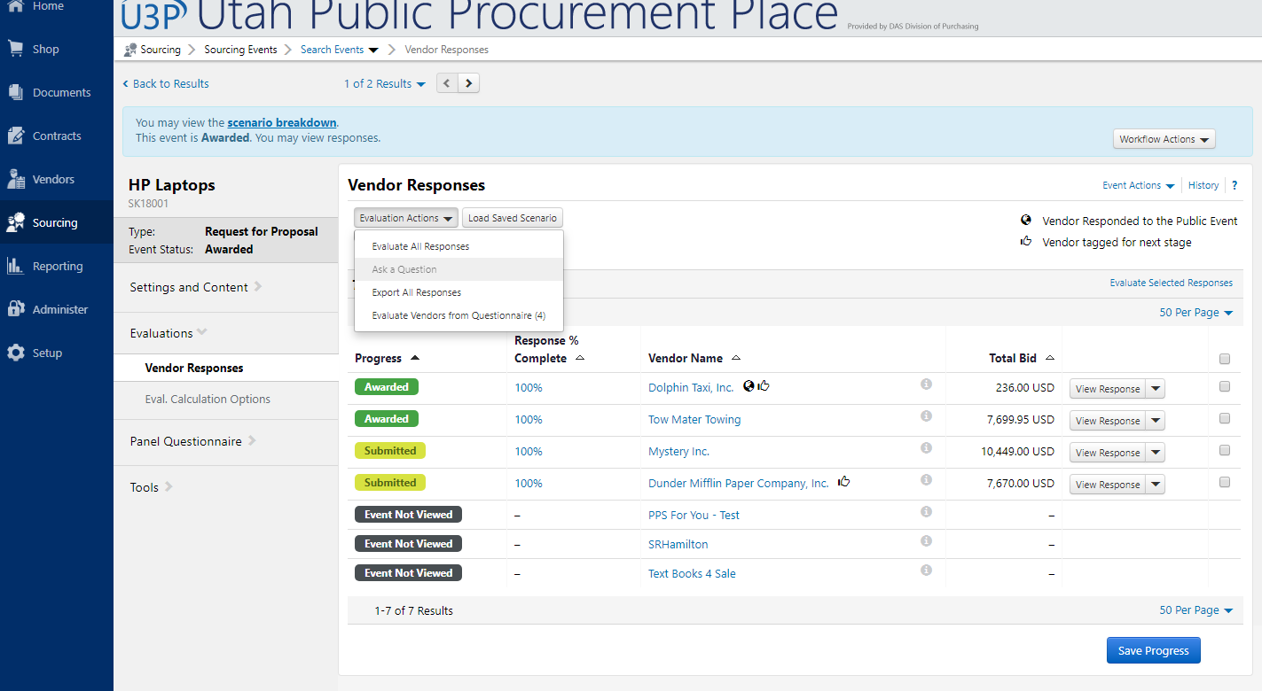

- Select the Scenario Breakdown tab. Here you will see all awarded vendors from your sourcing event. Select Create Contract to the right of your vendor.
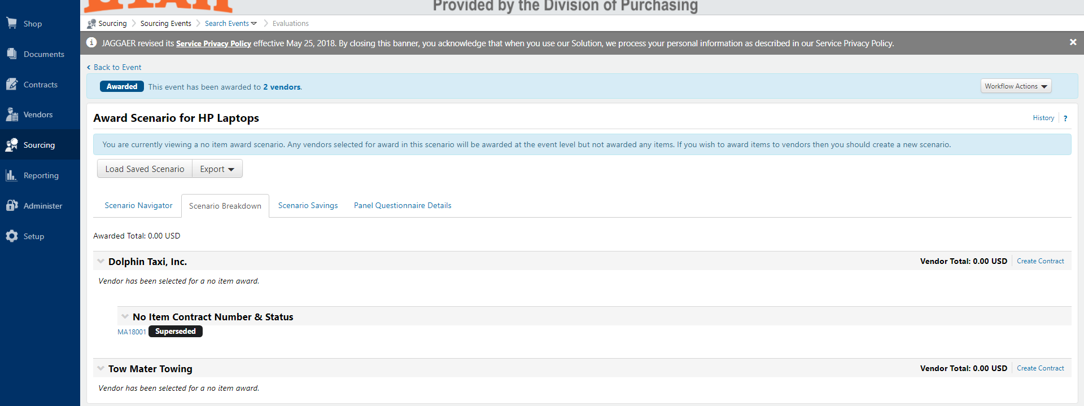
- Provide your Contract Name and set your Contract Type from the dropdown menu. Ensure the Work Group displays your entity name. Select your Main Document Template. This is your contract cover sheet. Select Next.
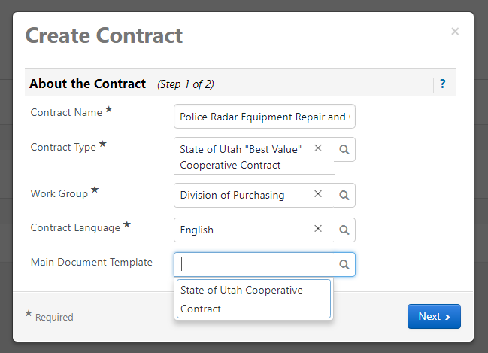
- If you utilized the Items section in your RFP, select the items this vendor was awarded to include in your contract. Otherwise, select Create Contract.
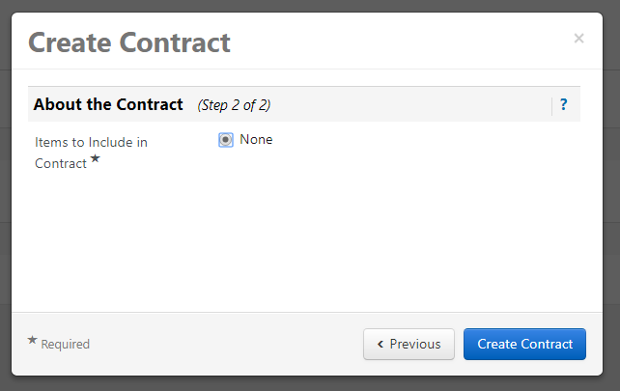

- Your created contract is displayed below in draft. Select your created contract.
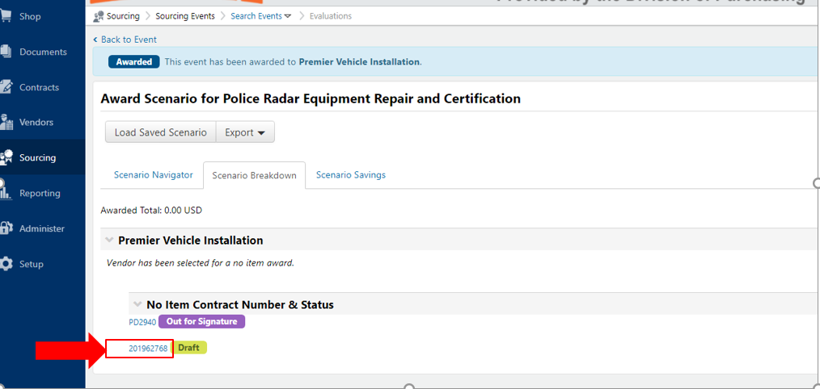

- Select Go to Contract.
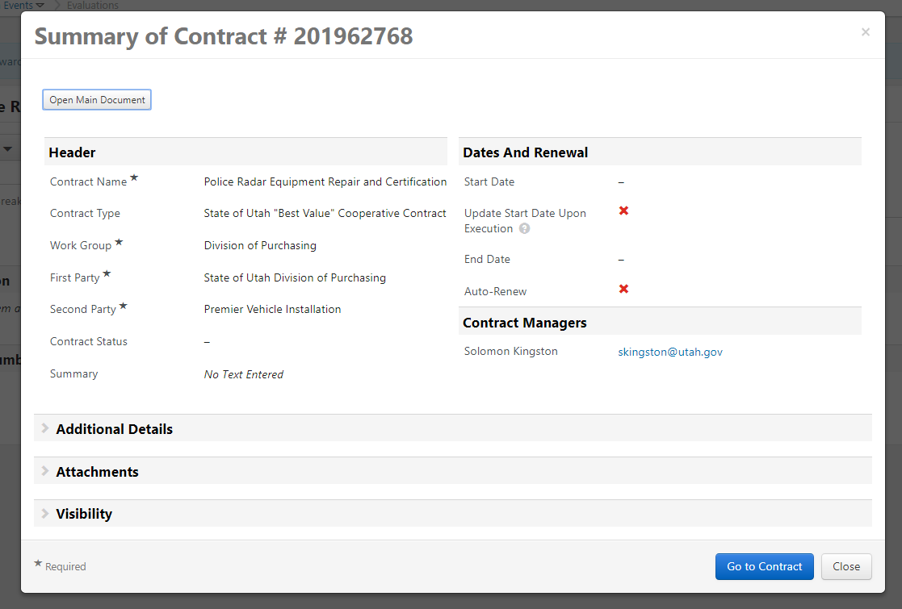

- Here is your new contract. This training guide will focus on the basic features for developing a contract utilizing the following sections: Header; Attachments; Review Rounds; eSignature; Submit for Approval; and Notifications.
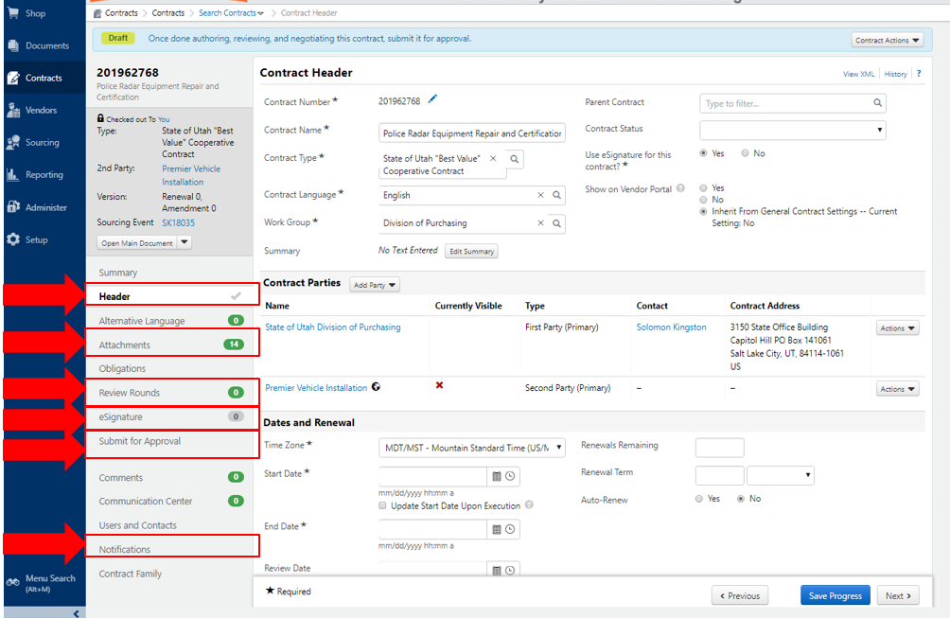
- Within the Contract Header section:
  - Change your Contract Number by selecting the pencil icon to the right of the number. Note, the contract # must be a unique #.
  - Verify the Contract Name is correct.
  - If you will utilize an eSignature solution to sign your contract, ensure Yes is selected.
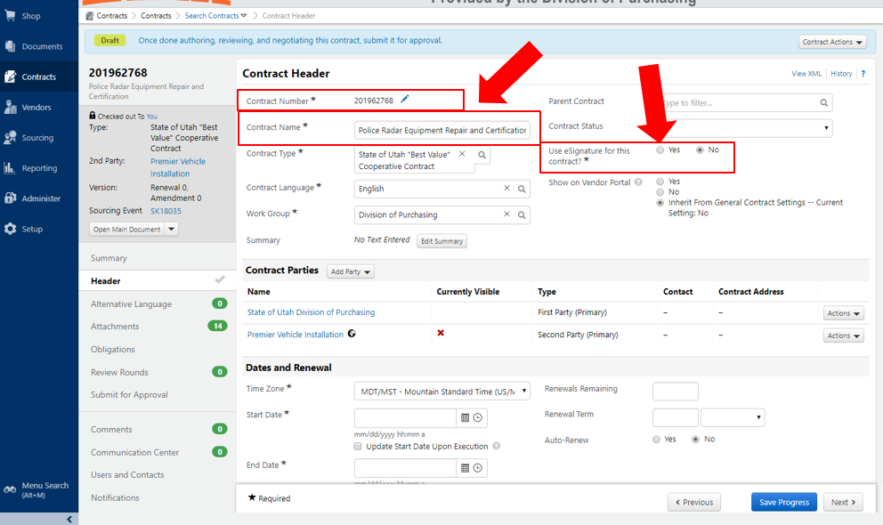
  - If you are awarding a contract to an incumbent (and using the same contract number), add a “-1” to the end of the current contract number in the Contract Number field under the Contract Header. For example, “MA1234-1”. The “-1” is an internal number and would only be used in the contract number under the Contract Header section. Make sure to use the current contract number without “-1” in the area below:

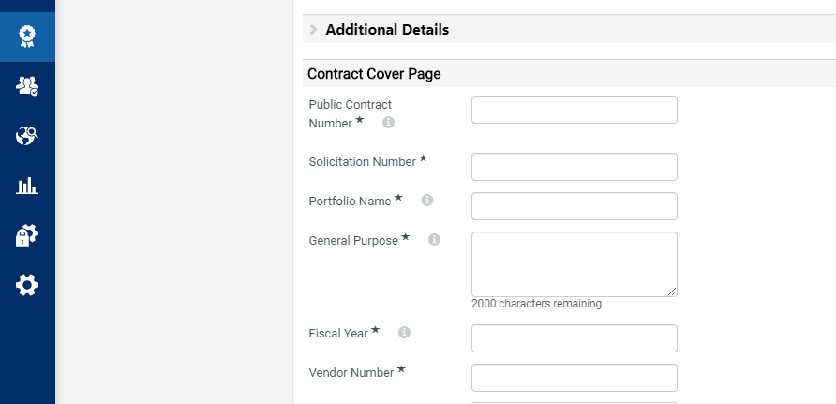

- Within the Contract Parties section:
  - The parties listed here are the Work Group name, and the awarded vendor. Add the Contact and Contract Address by selecting Actions.
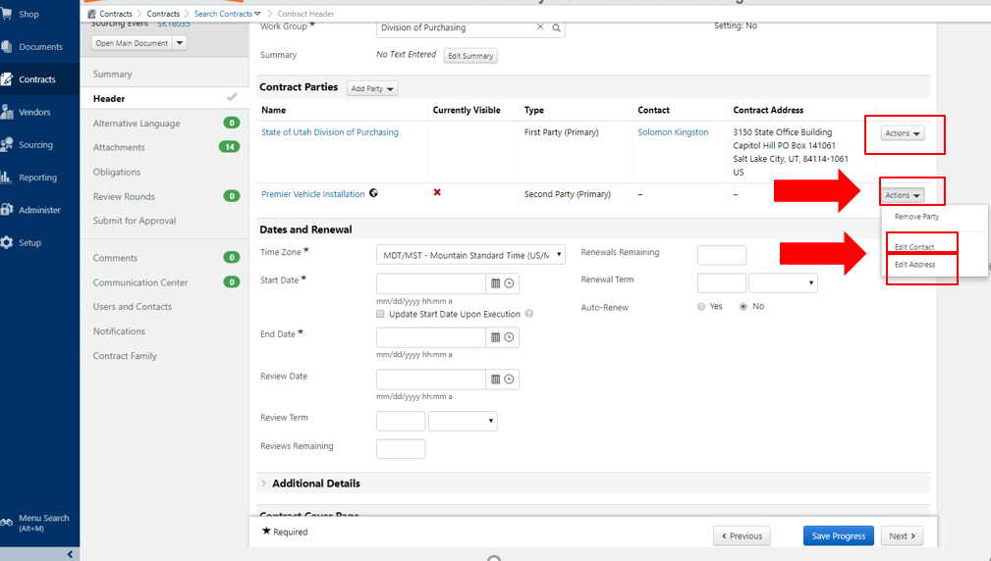

- Within the Dates and Renewal section add your contract Starting Date and End Date.
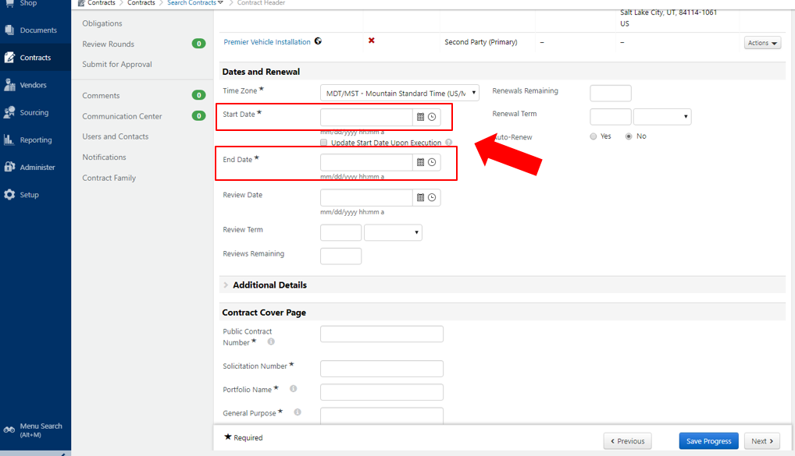

- Within the Contract Cover page section add your contract complete all required fields with an asterisk (*). You may select the information icon (i) for assistance on what information is required in a given field.
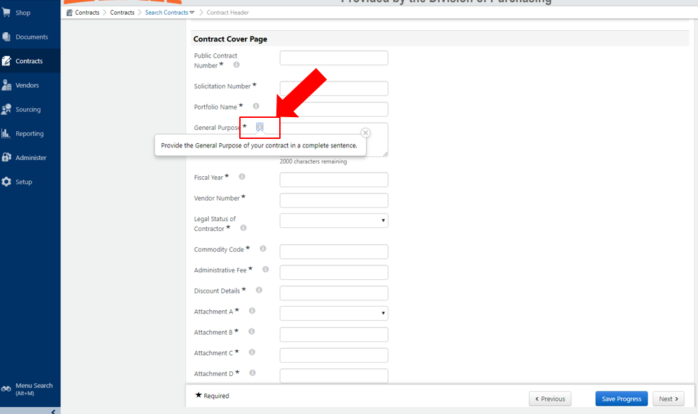

- Ensure to Save Progress before leaving the Headers page (section).

- Within the Attachment section:
  - The Main Document is your contract cover sheet. This coversheet is auto populated by the data provided within the Header section.
  - The Print with Full Contract column signifies those documents that will be included within your full contract.
  - You may select Add Attachments to add any number of attachments to your contract.
  - The order attachments are listed, is the order the attachments will be displayed in your contract.
  - Utilize the Actions icon to the right of a document to upload a new version, remove the attachment, change the document display order, change whether the document will print with the full contract, etc.
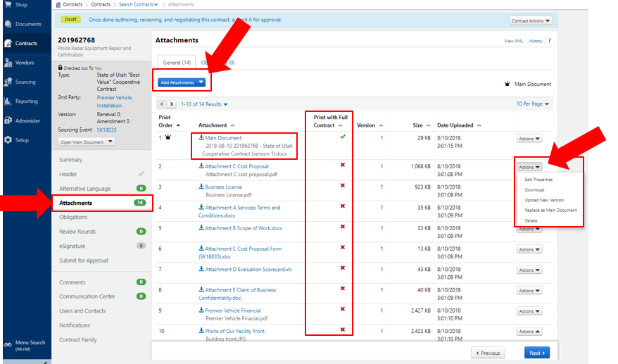
- Within the Review Rounds section:
  - Create an Internal Review Round to have your contract reviewed by those internal to your organization, who have a Jaggaer / SciQuest account.
  - Create an External Review Round to have your contract reviewed by those external to your organization, who do not have a Jaggaer / SciQuest account. I.e., this is where you’d have your Contracted vendor review the contract.
  - When a contract is under a Review Round, it cannot be edited by the Contract Owner.
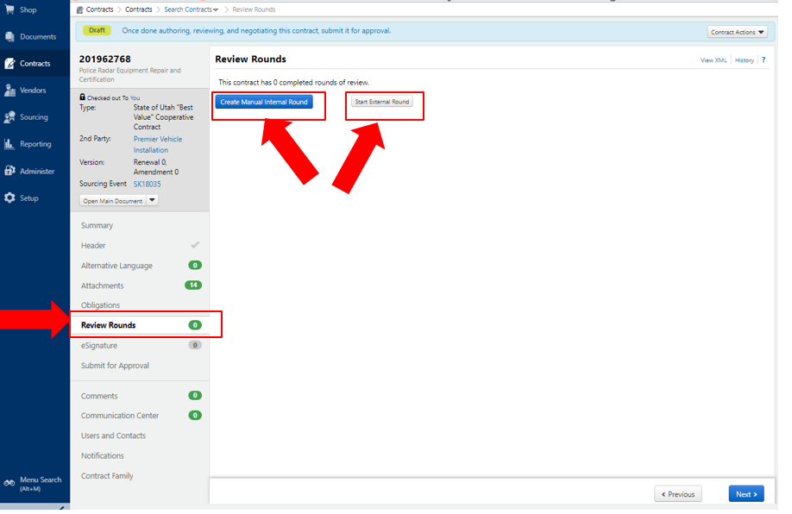

- Within the eSignature section:
  - Notice the default that Signers will sign sequentially.
  - Select Add Signer to add the Signers to your contract. Each signer must be added individually.
  - All Signers must be tied to one of the Contract Parties provided in the Header section.
  - You may select the Edit option next to a given signer to change the signing order or signer information.
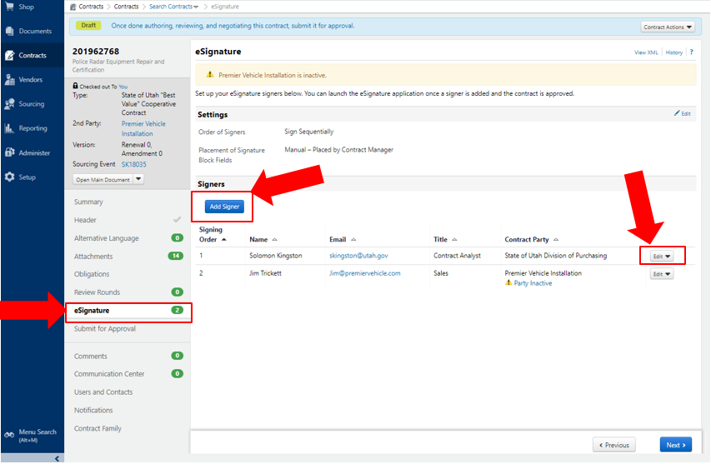

- Within the Notifications section:
  - Set an automatic schedule for when to be notified of key events on our Contract.
  - Set a Notification Type to send an External Contact notifications when your contract is nearing expiration.
    - The name of your External Contact is set in the Users and Contacts section. See next section.
  - Set the Advance Notice Settings for when your contract is nearing expiration.
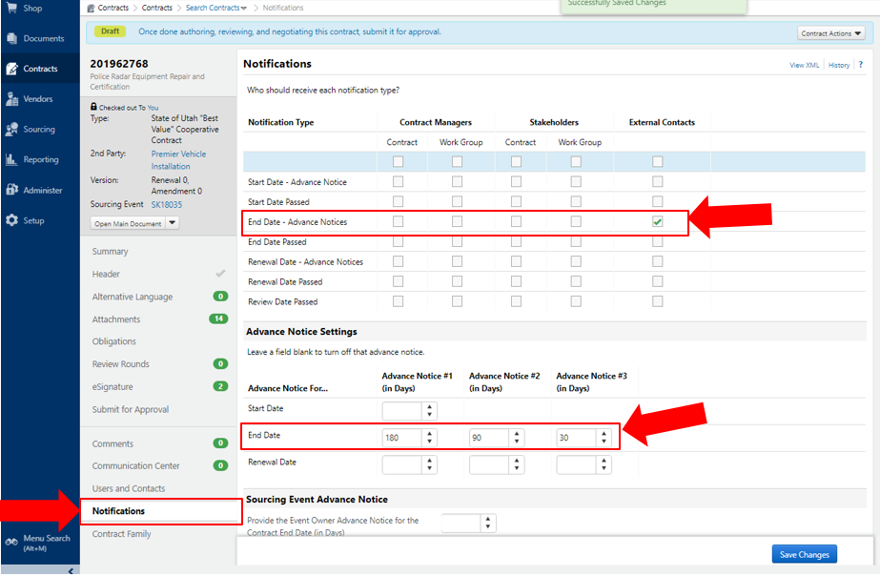

- Within the Users and Contacts section:
  - Select Add Contacts to add external contacts who should be notified when your contract nears expiration.
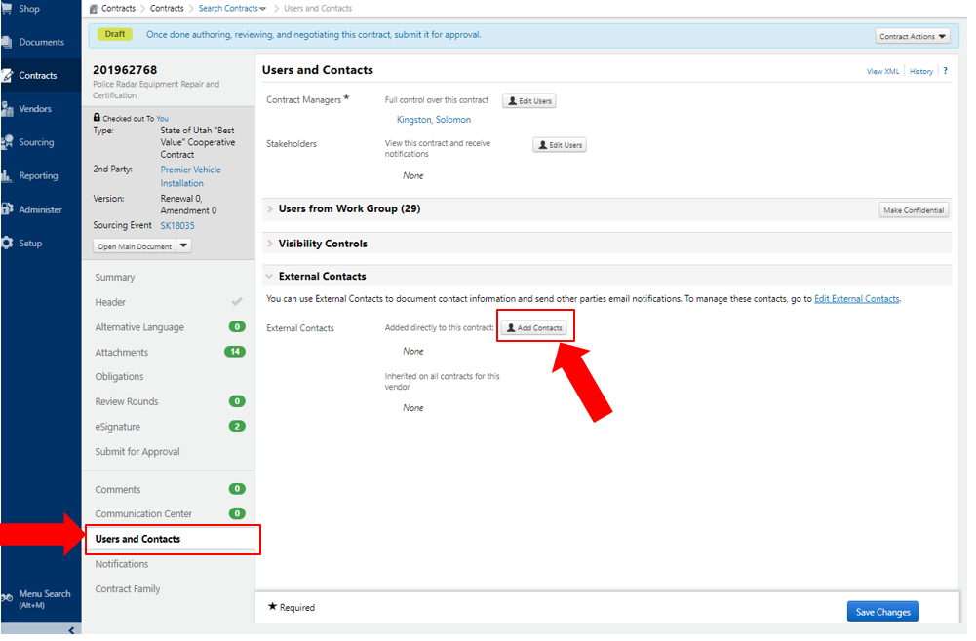

- Within the Submit for Approval section:
  - When you have completed drafting your contract select Submit for Approval.
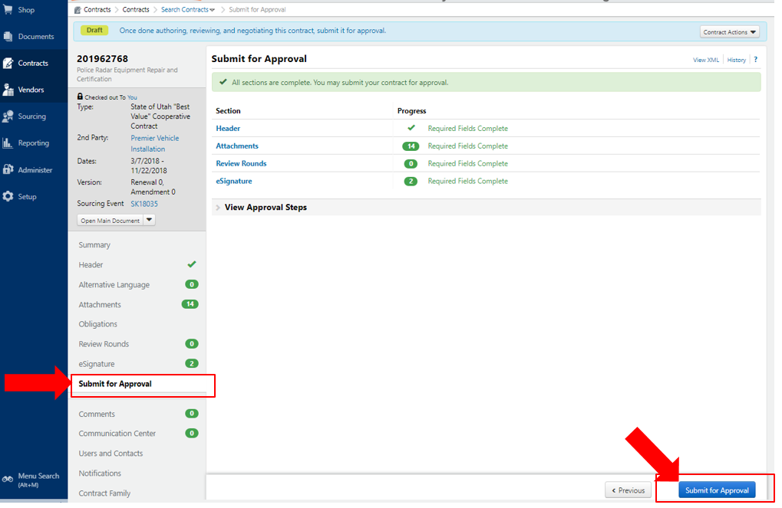
- Give your contract a minute or two to process through the Approval Workflow.
  - When the workflow is complete, and the status on your contract provides Pending Signature, select Contract Actions.
    - Here you may select Launch eSgianture or Upload Fully Executed Contract. See eSignature training guide if you are signing your contract through an eSignature solution.
