eSignature Process in
Total Contract Management and Adobe eSign

Step By Step Instruction for Public Entities

Provided by:
For Questions Contact – sciquestadmin@utah.gov

- At this phase TCM should show the status of your contract in the light blue pane as Pending Signature – This contract is awaiting eSignature setup.
  - Select Contract Actions > Launch eSignature
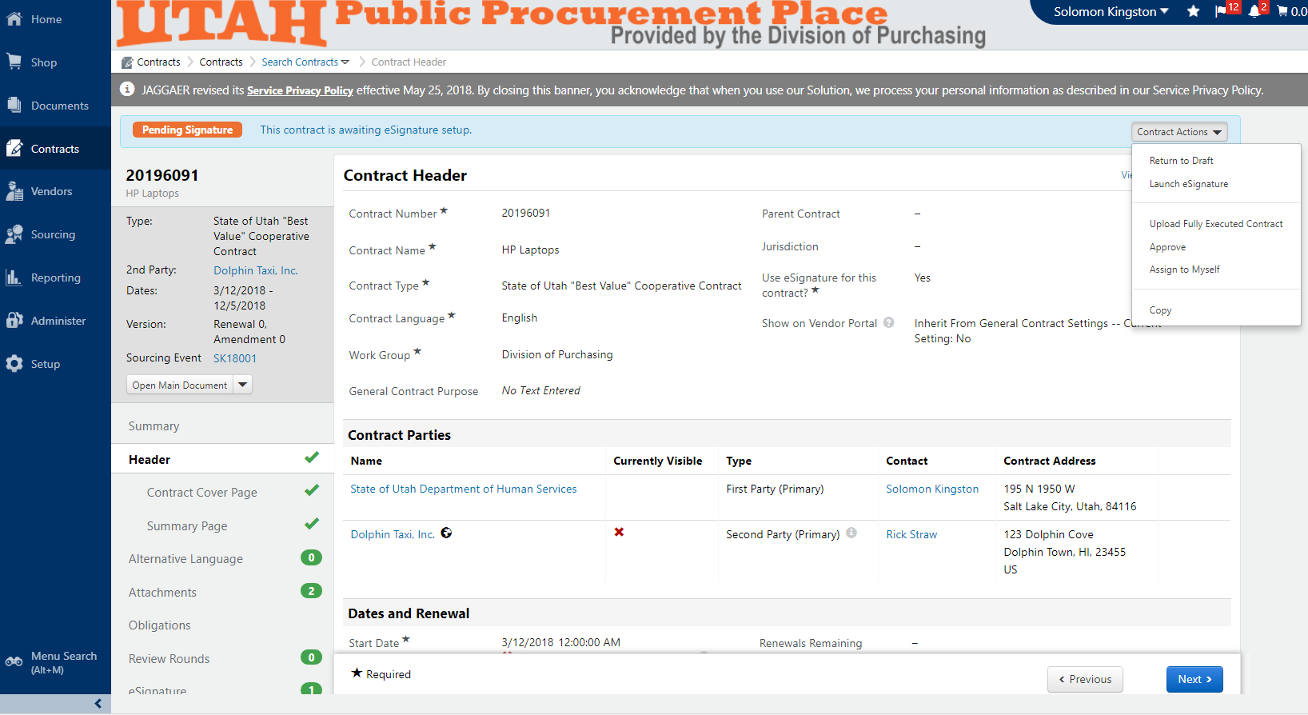

- You are then routed to your eSginature provider’s webpage. In this example Adobe eSign is being used. Your full contract is displayed.
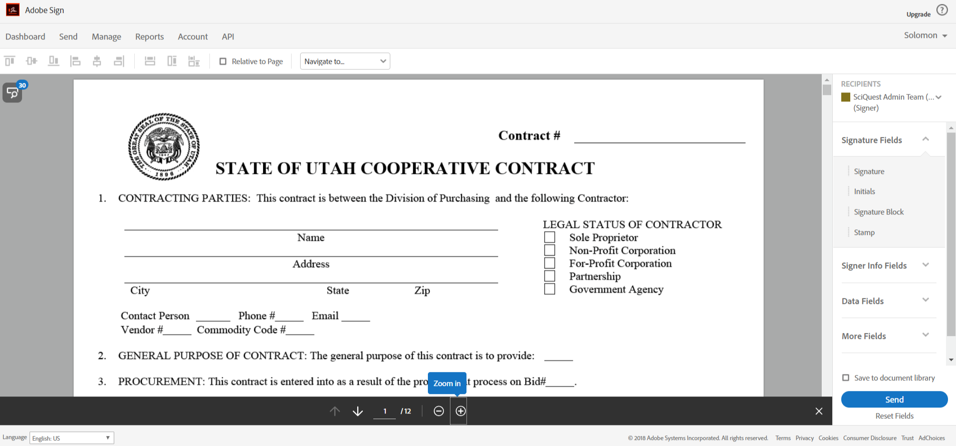

- Navigate in your contract where signatures are required.
  - Top right of screen shows your signers available. If your signer is not listed, it is because you did not list the signer in TCM.
  - Check the box for the first signer you are placing signatures for. In this example SciQuest Admin Team is checked.

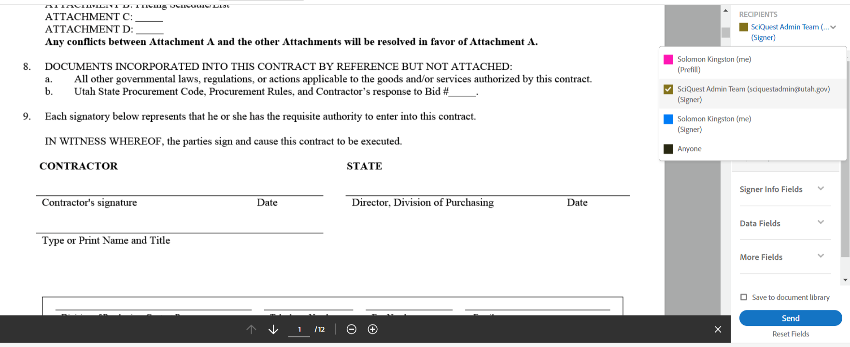

- Drag and drop the Signature Fields to where that 1st signer will sign in the contract.
  - You can adjust the size of your placed fields by selecting the bottom, right corner of the field box.
  - There are multiple fields available including: Signature, Name, Date, etc.
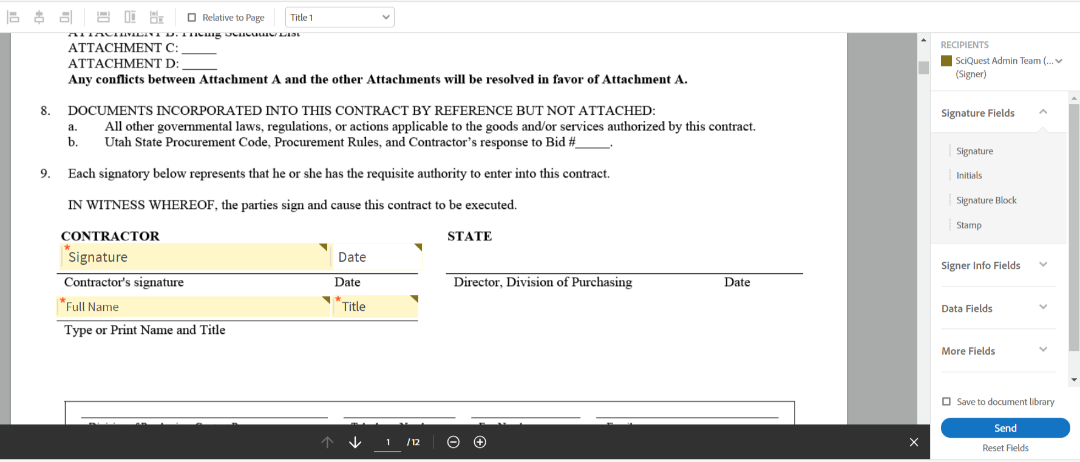

- For your 2nd signer select your 2nd signer from the top right “Recipients”. In this case Solomon Kingston is selected as the 2nd signer.
  - Now place the signature fields for this 2nd signer.
  - Notice how the fields for this 2nd signer are coded in blue, which coordinate to the blue box next to the Recipient name in the top right.

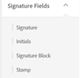
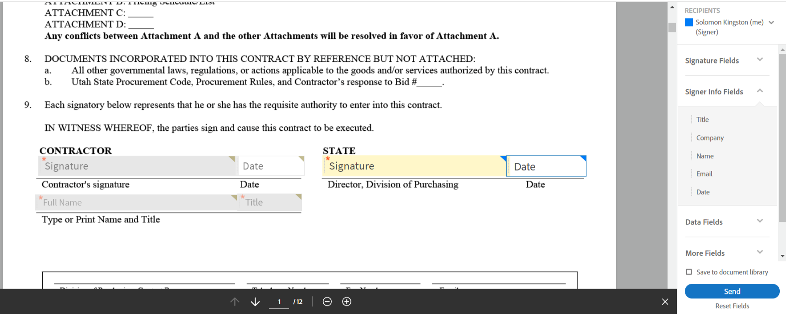

- After your signature fields are placed, click Send at the bottom right.
  - After clicking Send your contact has been emailed to the 1st signature party for signature.

- The 1st signing party receives an email that your contract is ready to sign. Within the email the 1st party clicks the hyperlink – Click here to review and sign.
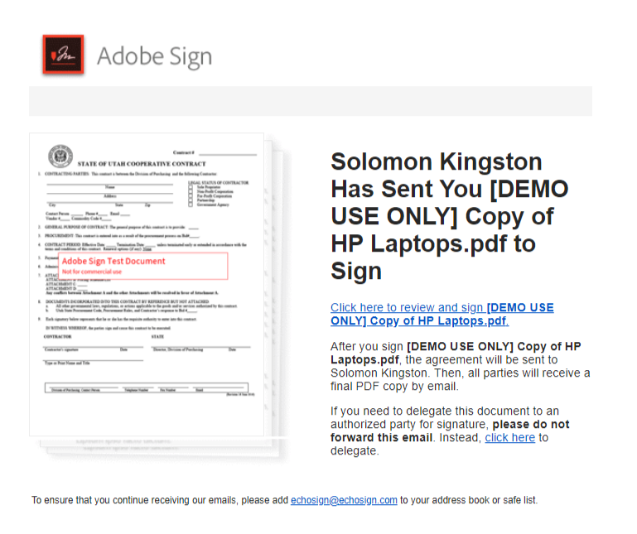

- 1st party is directed to the Adobe webpage for signature. 1st party is also directed where to sign. 1st party can only sign and complete those signature fields that are assigned to the 1st party.
  - If the individual receiving the email isn’t the actual signer for the 1st party select Alternative Actions at the top left of the screen, then Someone else should sign.
    - Provide the name and email address for the actual signer.
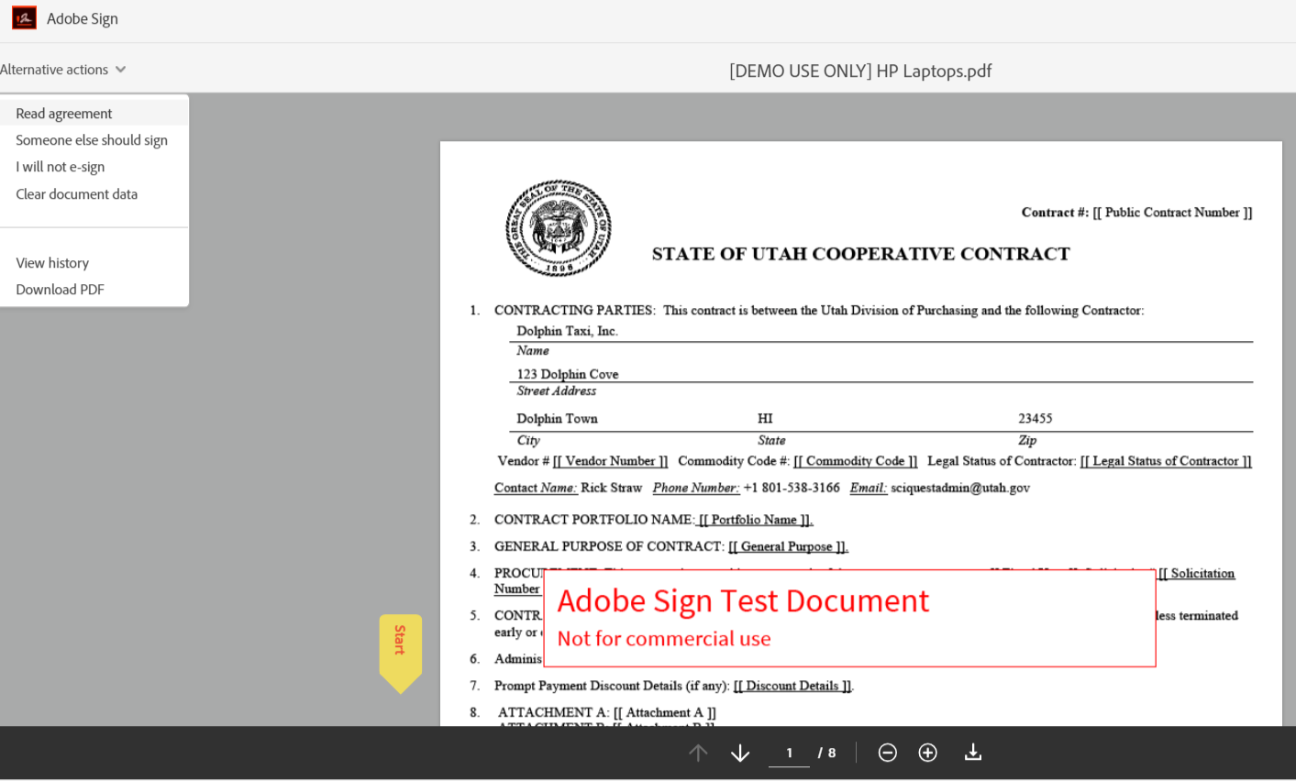
- When ready to sign, 1st party clicks Click here to sign.
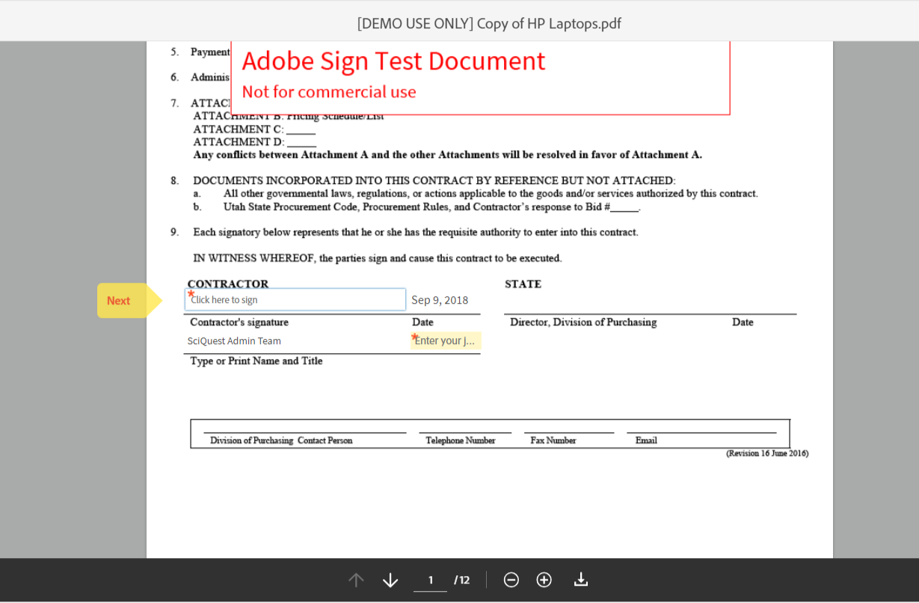

- 1st party has the option to Type its signature, Draw its signature, upload an Image of its signature, or send a text to its Mobile phone to sign with its fingertip.
  - Once signed, 1st party clicks Apply.
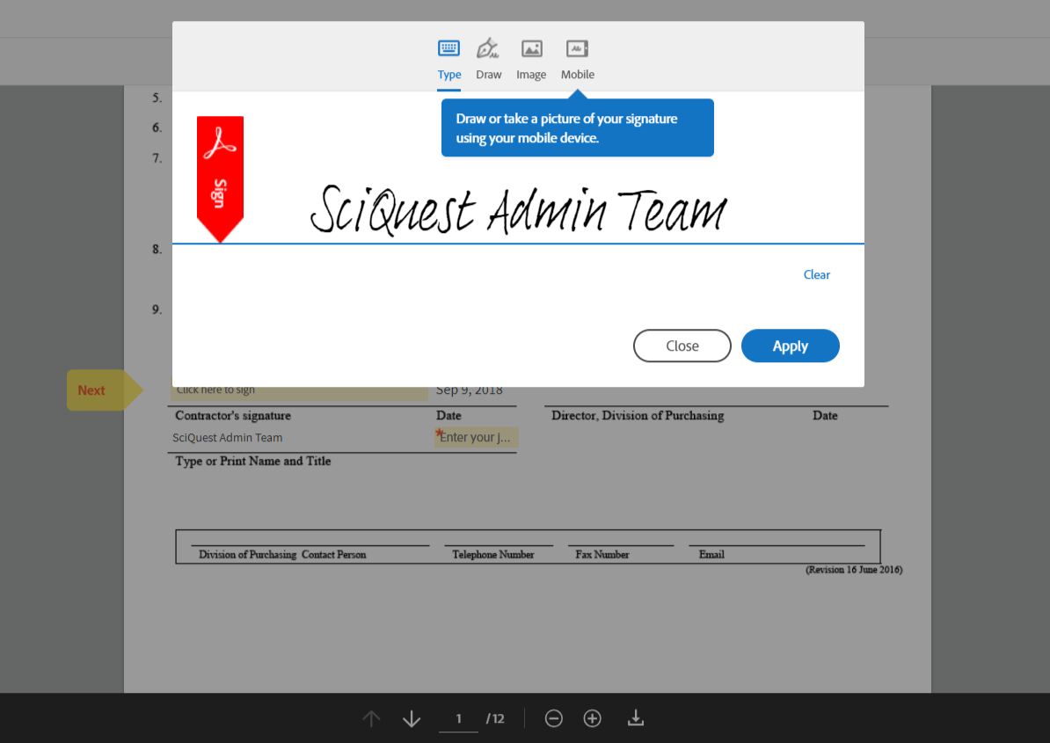

- 1st party completes all other required fields. When finished click Click to Sign.
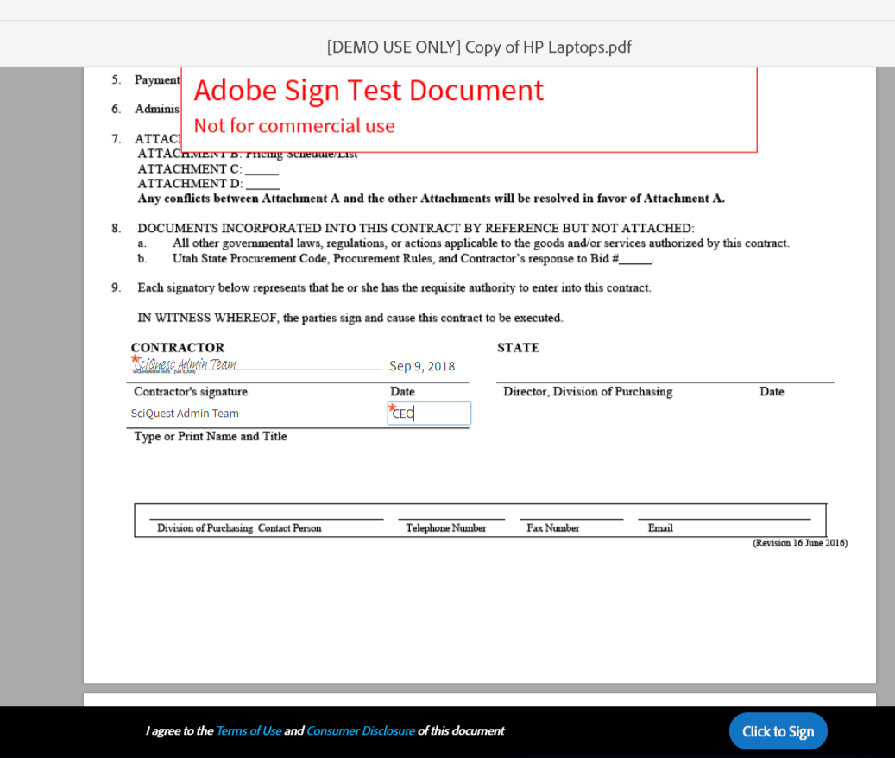

- 1st party receives confirmation that contract is signed. Next signer in the process automatically receives an email requesting 2nd party signature.
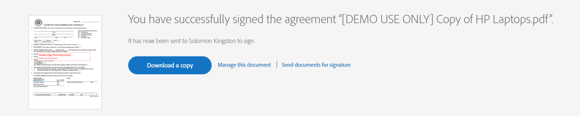

- 2nd party follows the same process as 1st party to eSign the contract. Once all parties have signed then all parties receive a fully executed copy of the signed contract via email.

- Within the Jaggaer TCM interface, after contract is fully signed, contract’s status will update to Executed.
  - Within the eSignature pane you can also see an audit history of when each signing party received, viewed, and signed the agreement.
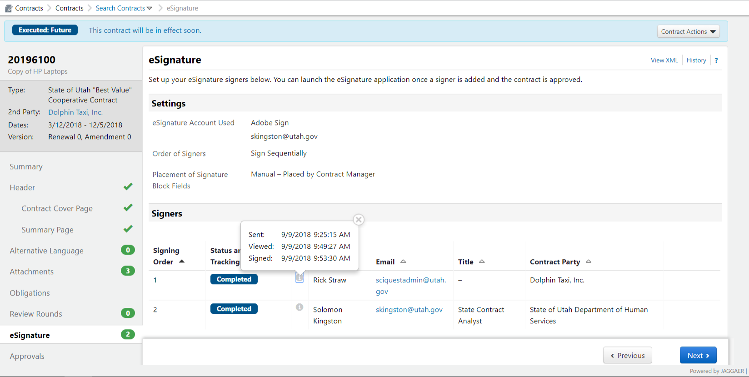

- The fully executed contract is also already uploaded in TCM within the Attachments pane.
  - There is no required action on your end to upload the Fully Executed Contract.
  - Select the Fully Executed Contract hyperlink to download and view your contract.
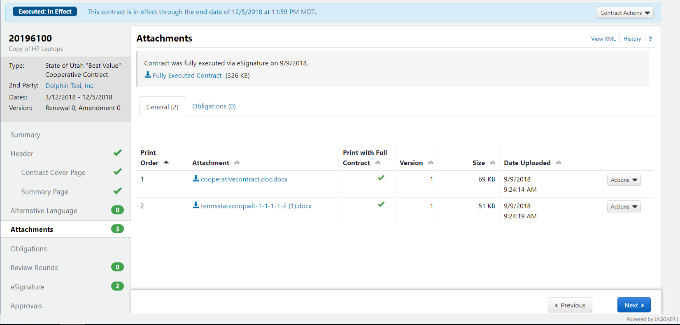

Your contract is now fully eSigned and uploaded in TCM.

